**Web-View:** A Web-based TLE Reviewer for the preparation of Industrial Arts Students in Licensure Examination for Teachers

A Research

Presented to the

Faculty of the College of Industrial Education

TECHNOLOGICAL UNIVERSITY OF THE PHILIPPINES

Manila Campus

In Partial Fulfillment

of the Requirements in

PROFED 14-M Thesis Writing

Macabasag, Ralph Christian

Gascon, Hannazeil N.

Mabanan, Joana Grace Z.

Arcilla, Jemmel Anne V

Empeniado, Edzil Jay I.

BSIE-IA-4A

November 2022

**TABLE OF CONTENTS**

# Preliminaries

Title Page ……………………………………………………………………………… i

Table of Contents ……………………………………………………………………. ii

List of Tables …………………………………………………………………………. iii

List of Figures …………………………………………………………………………. iv

# Chapter 1 - The Problem and its Background

Introduction …………….……………………………………………….…………… 1

Objectives of the Study ………………………………….……...…...………...…...

Scope and Limitations ………...……….………………………….……………......

Significance of the Study ……………….……….……………………………...…...

# Chapter 2 – Review of Related Literature and Studies

Review of Related Literature ...……………………………………………...………

Conceptual Model of the Study ………………….…….……………………...…...

Operational Definition of Terms …………………………………………………….

**Chapter 3 – Research Methodology**

Project Design…………………………………….…….……………….……...…...

Project Development………….………...……….…………………….…….….…..

Operational Testing and Procedures....……….………………….……….……...

Evaluation Procedure………………......……….………………...………….……...

Bibliography………………………….......……….………….….……...….…..……..

Appendices…………………………………………………………………………….

List of Table

Table 1: Scoring System ………………………………………………………………..

List of Figure

Figure 1: Concept Model of Web-View

Web-based TLE Reviewer “WEB-VIEW” ……………………………………

Figure 1.1. Spiral Development Model of the Program ……………

Figure 2: Context Diagram of Web-View

Web-based TLE Reviewer “WEB-VIEW”……………………………………………..

Figure 3: Use Case Diagram of Web-View ………………………………………..

Web-based TLE Reviewer “WEB-VIEW”…….

Figure 4: System Flowchart (Student/User) …………………………………………

Figure 5: System Flowchart (Administrator) …………………………………………

Figure 6: Waterfall Model ……………………………………………………………..

Figure 7: Web-View Interface design ..………………………………………..

Figure 8: Building Web-View using Visual studio code

Figure 8.1. Using Java Script ………………………………………………..

Figure 8.2. Using Hypertext Preprocessor …………………….……..……

Figure 8.3. Using Hypertext Markup Language …………………..………

Figure 8.4. Using Cascading Style Sheet ………………………………...

Figure 8.5. Using Xampp ……………………………………………………

Figure 9: Web-View Features Design Layout for Students/Users

Figure 9.1. Web-View Dashboard …………………………………………..........

Figure 9.2. Web-View Practice Test ………………………………………………

Figure 9.3. Web-View Notepad …………………………………………….……..

Figure 9.4. Web-View Downloadable Files …………………………..…..…….

Figure 9.5. Web-View Student/User Record Status ………………..……...…

Figure 9.1. Web-View Glossary and Web Developer About …………………

Figure 10: Web-View Features Design Layout for Teacher/Instructor……………….

**Chapter 1 THE PROBLEM AND ITS BACKGROUND**

**Introduction**

The Web-View website will serve as a study manual and reviewer tool for College of Industrial Education 4th Year BSIE IA Students at the Technological University of the Philippines Manila, as well as a significant aid for students who have difficulty affording review centers. Any mobile device, laptop, or computer can access it accessible at any time from any location. Pre-service teachers will use the website mostly at work, classroom, and at home. The Web-View website enables students to develop their critical thinking and reading comprehension skills while also supporting them in making the most of their time by allowing the users to answer various questions the teachers upload on the website. Additionally, references from online sources in the form of websites include written resources for them to further review. Web-View, a reviewer for the LET Exam, is a website that provides a set of questions about Specialized courses taken by CIE students. It includes basic introductory information on the four areas of TLE, especially in the Industrial Arts course. It consists of a series of questions that will gauge the student's level of learning. The website will also determine the student's level of exam preparedness. This website was made to assist LET takers who want to utilize a practical and cost-free online digital free let reviewer.

**Background of the Study**

When covid pandemic struck, most academic institutions and professional organizations developed supplemental materials for education based on e-learning platforms, online programs, continuing education sessions, or webinars. The shrinking teaching force and the shift from face-to-face to online virtual platforms affect students' academic performance. Due to the government-mandated restrictions on community quarantine and the limited study materials and facilities, many takers who took the Licensure Examination for Teachers (LET) struggled immensely to pass.

The modern world is dynamic. People frequently adopt traditional learning techniques to newer, more creative ones. Technology has allowed the transition of review materials from a traditional textbook to an online-viewable electronic document. More people are using technology as it becomes more commonplace to produce work faster and better than they would have otherwise. Several programs are created using the most modern technology available for study guides. Technology is continually changing how we work and play to create and communicate. (Lathan, 2022) It helps us to make our daily activities more accessible by using the modern technology that we have. It improves our quality of life and becomes more convenient. Technology can automate manual tasks, including communications, information, and better learning opportunities (Nagasubramani, 2018). Schools today already use technology as one of the teaching materials, especially for teachers who use computers for education. Even students can easily access or obtain some reading materials using gadgets and the internet by searching for what they need; as long as we have access to the internet, we can quickly get some reading materials that we need, even if we are not in the library or school but also because of that we can get unreliable sources. reading inaccurate information can affect students performance on subsequent tasks."We're bombarded with tons of information all day; it's a nightmare to critically evaluate all of it," said D. Rapp, 2016 who coedited and contributed to the book "Processing Inaccurate Information."

. In the course of a student's life, exams have always been present. They serve as a means of evaluating a learner's level of familiarity with the topic or topics that the exam will cover. Examinations can be given orally on paper, on a computer, or in a small space where the test taker must physically accomplish a set of tasks. For most degree programs, candidates had to sit for and pass licensing or board exams. By the use of the standard test, these exams are given. Additionally, standardized tests will help identify a person's strengths and shortcomings because they will give an overall picture of his skills.

The Republic Act No. 7836, also known as the Philippine Teachers Professionalization Act of 1994, supervises and regulates teaching practice in the Philippines. All aspiring teachers are required to take and pass the Licensure Examination for Teachers (LET). The test taker must achieve a minimum weighted average of 75% to pass the licensure examination. LET manages two levels of examination. One is for the Elementary level, and the second is for the Secondary level. For the elementary level, LET covers 40% of general and 60% of professional education. At the secondary level, LET covers 20% of general education, 40% of professional education and 40% of the major subjects studied. (Jasper Klint de la Fuente, 2022)

In the Philippines, candidates who wish to pursue teaching careers in public and private schools and universities must pass the Licensure Examination for Teachers (LET). The most frequent issues that students face when taking the exam are that no review facility will assist them in evaluating the test for them to pass reviewing for their LET exam, and they must purchase review materials like textbooks, and manuals, which results in expending money. Therefore, we proposed a Web-View, a LET reviewer that enables them to easily prepare and review for the licensure exam without expending money. The sample question sets on this website aimed to focus on the specialized courses taken by BSIE IA students at the Technological University of the Philippines, which include Agri-Fishery Arts, Home Economics, Information and Communications Technology (ICT), Industrial Arts (Automotive, Carpentry, Construction Techniques, Refrigeration and Airconditioning, and Electrical and Electronics) which allow students to take review tests on their phones, laptops, computers, and other mobile devices that can run Web-View.

Hence, the factors mentioned above encouraged the researchers to develop a Web-View that will assist CIE students who are LET reviewers in having access to personalized review materials that are friendly, convenient, and on-the-go resources, as well as self-paced learning, for them to review for the LET exam.

# Objectives of the Study

**General Objective**

The study's main objective is to develop and provide a free instructional review resource for College of Industrial Education 4th Year Industrial Arts Students that will take the Licensure Examination for Teachers (LET). It aims to help the student teacher hone their analysis and reading comprehension and maximize their time while answering different questions the website compiled and recapping past lesson that IA students took.

**Specific Objective**

Specifically, the study aims to:

1. Design and develop the Web-View with following features:
2. Compile, manage and upload digital learning materials.
3. Integrate downloaded file, Notepad feature, glossary, and Practice test.
4. Manage students records and status progress per courses.
5. Provide a web-based review material which are friendly, handy, and on-the-go resources and support the CIE students who ought to take LET to a self-paced learning.
6. Develop the Web-based TLE Reviewer system in Java Programming using the following: Visual Studio code, Hypertext Preprocessor, Hypertext Markup Langauge, Cascading Style Sheet, and Xampp.
7. Evaluate the acceptability of the developed web-based in terms of the following:
8. Functionality
9. Reliability
10. Usability
11. Efficiency
12. Maintainability
13. Portability

**Scope and Limitation of the study**

The focus of the study is to develop a Web-based TLE LET module reviewer, which aims to help the students let takers practice obtaining knowledge and skills in the said specialized subjects. Moreover, the study will also intend to enhance their reading comprehension, analyzation, time management, and ability to increase the range of strategies for effective transfer. The Web-View will only focus on the TLE specialized subjects including, Agri-Fishery Arts, Home Economics, Information and Communications Technology (ICT), and will solely focus on Industrial Arts with its areas (Automotive, Carpentry, Construction Techniques, Refrigeration and Airconditioning, and Electrical and Electronics). The researchers will only develop the website for technical use of the Admin, Teachers and the Students and will be limited to upload content from the curriculum and ……

Students using the Web-View will be allowed to download any modules uploaded on the system in a sequential or structural format. Despite the lack of internet availability of their own, they can still utilize the website (reading and viewing feature) if they download the file on their mobile phones using the download feature. The user can also go to any nearby internet shop to rent or use personal smartphones, tablets, or laptops to register in any prepaid load internet connection, pocket Wi-Fi, or even for hotspot usage since the system is responsive, web-based, and always reachable.

Users can use the notepad features on the Web-View to take notes while reading and highlight critical passages to refer to what they have already learned. It works more like a sticky note feature to remind the user of what they have learned. Additionally, the website will include a glossary feature that will display terms, phrases, and abbreviations in alphabetical order, along with their definitions. Lastly, the Web-View will strive to provide a practice test function to evaluate their learnings and to check their readiness for the exam, reading comprehension, analytic skills, and so forth. Additionally, a timer option involves for the abovementioned use.

Teachers who use the web-view will be able to upload a Portable Document Format (PDF) file of lessons on every subject because a PDF file will always display any amount of data, such as paragraphs, images, vector graphics, tablets, etc., in the same way regardless of where you are viewing it. Teachers can also modify modules by inserting, editing, or deleting information on the web-view. They can also create assessments, input a timer in every practice test, and insert links, and images that would be helpful for students who wish to pursue a career teaching in the future.

With the assistance of teachers who will serve as the sources of information, lessons, and assessments in each module, the study will concentrate on creating web-based review materials that would be an excellent tool to assist students who lack the financial means to enroll in review centers, buy books and find reliable site information on the internet.

# Significance of the Study

This section provides a brief description of the significance of the study for the following entities:

**To the future researchers** – This study will benefit individuals who want to learn and explore a web-based project to expand their knowledge of website-based reviewers. This will help and give insights about the development of review website materials to future researchers who will conduct similar studies.

**TLE major LET Takers –** The potential beneficiaries also include the individual who wishes to pursue taking the Licensure Examination for Teachers. According to Find University.ph (2022), the ranking of TUP Manila first-timers on the LET examination is five hundred sixty-five (565), and only fifty-five percent (55%) can pass the board. Since our website is focused on specialized TLE subjects that are frequently among TUP students who take the exam, most fail. It varies from websites such as Professional Education, General Education, and Major subjects. The finding of this study will help the CIE students to pass the LET exam in major subjects wherein they can access free resource material.

**To Teachers** – The project will be a tool for teachers who instruct Seminar in Technology and Livelihood Education for Teachers (SEM2) and other related TLE courses to update their resources to enhance student learning and to create a deeper understanding of the subject matter.

**To Technological University of the Philippines** – This study will give insight to the members and staff of Technological University of the Philippines on what is the efficiency of Web-View in the body of development and innovation.

**To the future students of BSIE IA** – The study will help the students by giving them information about the Web-View that could give enormous impact to their future study and LET practices.

**To the proponents** – The study will improve the proponent’s knowledge on the development of Web-View: A Web-based TLE Reviewer for the preparation of Industrial Arts Students in Licensure Examination for Teachers and will help the formulation of analytic recommendation to the Technological University of the Philippines as a member of the organization.

**Chapter 2**

# REVIEW OF RELATED LITERATURE AND STUDIES

The review of related literature and studies focuses on the following topic to support the studies feasibility and relevance: Review of Related Literature and Studies, Research Paradigm, and Operational Definition of Terms.

**Review of Related Literature and Studies**

The development of the project in some aspect runs parallel with studies conducted by various researchers in different subject areas.

**Need-Based Reviewer in TLE**

According to Limo (2010), in his study about the Need-based Reviewer in Technology and Livelihood Education for the licensure examination for teachers, it is concluded that the reviewer in T.L.E. is a functional material in preparing education graduates whose major is technology and livelihood education to take the Licensure Examination for Teachers. LET-T.L.E reviewer prepares graduates for the board examination in the different components they are not trained in. It has a content update in each element or practice test item that guides the target user in identifying the correct answer. Moreover, the reviewer was found highly valid as to objectives, contents, instructional materials, and practice test items; hence they are expected to assist the TLE graduates to pass the L.E.T.

**Self-review**

According to Darling-Hammond & Lieberman, reflective practices have been considered an essential educational component within programs for teacher preparation (2013). Self-review is a type of reflective exercise that can be used with preservice teachers to improve their skills in providing and absorbing feedback. Self-evaluation promotes motivation, learning, and active participation in the learning process (Baecher et al., 2013; Case, 2007; Cheung, 2009). By helping preservice teachers see their strengths and weaknesses, self-review promotes the growth of autonomy, self-regulation, self-reflection, self-evaluation abilities, and goal planning (Andrade & Valtcheva, 2009). (Hanrahan & Isaacs, 2001; Carless et al., 2011; Case, 2013; Baecher et al., 2013). However, using peer and self-review with preservice teachers is difficult for teacher educators, according to various research (Boase-Jelinek et al., 2013; Meerah & Halim, 2011; Sndergaard & Mulder, 2012; Tricarico & Yendol-Hoppey, 2012). The logistics of the peer review process, such as coordinating the exchange of materials and facilitating anonymous peer reviews; Boase-Jelinek et al. (2013); student characteristics (such as a lack of knowledge or abilities to conduct a review); and teacher educator constraints, all contribute to these problems (e.g., timeliness of feedback and limited expertise in content areas; Hatziapostolou & Paraskakis, 2010). In using instructional resources such as manuals created by instructors, rubrics for peer and self-evaluation, and online review tools, teacher educators can address these challenges (Orsmond et al., 2000).

**Web-based instruction**

The Web has developed into an effective instrument for online education. Due to its intrinsic versatility can be used in various educational contexts, from straightforward student and course management to fully online course delivery. These varied uses all strive to accomplish distinct objectives. Since the Web was not directly used for education in this instance, evaluating its use in learning results might not be acceptable. According to Khan (1997) the term "web-based instruction" (WBI) refers to an innovative method of delivering training to a remote audience through the use of the World Wide Web as the platform. Web-based learning environments employ the resources of the Web to build an environment that supports and encourages learning. The Web has many distinctive qualities and capabilities that are beneficial to both educators and students.

***Knowledge Requirements***

**Operating Systems**

**Web Programming**

**System Analysis and Design**

**Software Engineering**

**Computer Network**

**Database Design and Management**

***Software Requirement***

**HTML**

HTML is still predominantly utilized as an output format alone. Papers are converted between various formats using the appropriate tools in the publishing toolchain. Documents are converted between different formats using the proper tools in the publishing toolchain. The authors draft their papers in LaTeX or MS Word and submit their sources to the typesetters, who are responsible for creating the definitive version, which will eventually be published and read on the Web.

Tim Berners-Lee created the initial iteration of HTML in 1993. Since then, HTML has existed in a variety of forms. HTML 4.01, which became a recognized standard in December 1999, was the most generally used version during 2000s.  A further version of HTML was developed as the XML language and is referred as XHTML. A common markup language named XML is used to create various markup languages. Now, there are hundreds of XML languages in use, such as RSS, MathML, MusicML, and GML (Geography Markup Language) (Really Simple Syndication). All these languages were written in a common language (XML), making it simple to transfer their content throughout software.

The coding that organizes a web page's content is called HTML (HyperText Markup Language). Content may be managed using paragraphs, a list of bulleted points, graphics, and data tables, among other options. HTML is a markup language that specifies how your material is organized. HTML comprises several components you may employ to enclose or wrap certain parts of the content to alter how it appears or behaves. The enclosing tags can italicize words, make the font bigger or smaller, hyperlink a comment or image to another location, and more.

**Cascading Style Sheets (CSS)**

The language used to describe how Web pages are displayed, including their colors, design, and fonts, is called CSS. It enables the presentation to be adjusted for use on many devices, including printers, tiny screens, and giant screens. CSS can be used with any XML-based markup language and is not dependent on HTML. In presenting material created using a markup language, CSS starts by selecting an HTML tag or a value associated with an HTML element. The CSS following this selection will change the formatting of every instance of that tag in the associated HTML. Haykon Wium Lie first developed CSS in 1994, websites were only intended for academic use; hence appearances were unimportant. The cascading aspect of CSS, which allows one style to cascade across multiple files, was inspired by the desire to enable a document's style to span multiple files. The development and standardization of CSS first fell under the purview of the W3C's HTML Editorial Review Board (ERB). Still, it gained enough sway that a separate group, the CSS Working Group, led by Chris Lilley, was established in early 1997.

**Hypertext Preprocessor (PHP)**

The server-side interpreted scripting language PHP, also known as PHP: Hypertext Preprocessor, was created by Rasmus Lerdorf in 1994 and made public on June 8, 1995. It was developed to be utilized in the creation of dynamic web pages and web pages that effectively communicate with databases. The acronym PHP stands for Hypertext Preprocessor and is a computer language. We can create things for the internet using PHP and other languages like HTML. Furthermore, PHP is open source, which permits unrestricted use by anyone. In actuality, PHP became the most widely used open-source web technology. Many developers use PHP, an open-source server-side programming language, to create websites. In addition, it is a general-purpose language that you can employ to make a variety of tasks, such as Graphical User Interfaces (GUIs). PHP ensures that the source code is processed into web pages filled with text, graphics, and other content that people, who cannot read codes, can see and utilize.

**Java and Java script**

By the late 1990s, Java had started to go beyond the Web, powering consumer electronics (like cell phones), retail and business systems, and bringing multimedia to the Internet. Due to its popularity, Sun created other Java variations for various applications, including Java SE for personal computers, Java ME for embedded devices, and Java EE for Internet servers and supercomputers. Java is now run by Oracle Corporation, which acquired Sun Microsystems in 2010. Java, a modern object-oriented computer programming language, was used to develop gadgets or web browsers. It was evident that the Web was a particularly suitable fit for it because of its potential for interactivity and multimedia, according to James Gosling (1995).

In 1995, Brendan Eich, invented JavaScript is a lightweight computer language called JavaScript is used to create interactive web pages. HTML can be updated with dynamic text. The language of the browser is another name for JavaScript. JavaScript (JS) and Java are unrelated to one another. One of the three primary scripting languages used to create webpages is JavaScript, which allows you to add functionality and behaviors to your website. In contrast, HTML and CSS give a website structure and appearance. This enables your website's visitors to interact with the material in various creative ways. It is a client-side language that runs in your browser on your PC. But more lately, JavaScript has also been able to run code on servers thanks to the development of Node.js. JavaScript has outperformed Java, Flash, and other languages since its inception because it is comparatively simple to learn, has a free and open ecosystem, and, most significantly, is immensely useful, allowing developers to create apps with audiences in the millions swiftly.

**Integrated Development Environment (IDE)**

**Visual Code Guide (VS CODE)**

Erich Gamma (2015) Microsoft recently introduced the latest edition of Visual Studio Code (VS Code), their wildly popular open-source code editor for Linux, macOS, and Windows. A Microsoft technical fellow developed VS Code. VS Code was first created using a combination of JavaScript and TypeScript. It eventually switched to TypeScript for all the code and became enamored with its enhanced tool support, featuring refactoring and static type checking. For some of the Node.js modules maintained, some native code is utilized. Indicated that it offers VS Code to macOS, Linux, and Windows, along with support for ARM-based processors, by leveraging Electron as an application framework. Chromium and Node.js allow utilizing the standard web APIs on which Electron is built. It started VS Code (formerly called "Monaco") and intends to make a higher browser-based code editor for web programming. Therefore, it seemed only reasonable that would leverage web technologies to develop Visual Studio Code so that could immediately see how effective it is for creating web applications.

It has built-in support for JavaScript, TypeScript, and Node.js and a robust ecosystem of extensions for additional languages and runtimes (including C++, C#, Java, Python, PHP, Go, and.NET). The style of VS Code is straightforward and user-friendly, maximizing the amount of room allotted for the editor while providing plenty of room to access and browse folders and projects in full context.

**Xampp**

***Hardware Requirement***

**Operating System: Window 8**

**Memory: 4 Gigabyte memory**

**Processor: Intel core i3**

**Processor 2.20 GHz**

**Storage: 200 GB**

# Research Paradigm



**Input**

1.

Knowledge Requirements

a.

Operating System

b.

Web and Mobile Programming

c.

System Analysis and design

d.

Software Engineering

e.

Computer Network

f.

Database Design and Management

2.

Software Requirement

a.

Programming language and

Database engine:

•

HTML

•

CSS

•

PHP

•

Java Script

b.

Integrated Development Environment

IDE

(

)

•

Visual studio code

•

Xampp

3.

Hardware Requirement

a.

Computer set connected to internet

with minimum requirements of

storage are the following:

•

Operating System: Window 8

•

Memory: 4 Gigabyte memory

•

Processor: Intel core i3

Processor 2.20 GHz

•

Storage: 200 GB



**Output**

**Web-View:** A Web-based TLE Reviewer for the preparation of Industrial Arts Students in Licensure Examination for Teachers

**Process**

Understand the Requirement

Design the system

Build-in stages

Test and Evaluate



**Evaluation**

1.

Functionality

User friendly

Portability

Functionality

Reliability

Usability

2.

Reliability

3.

Usability

4.

Efficiency

5.

Maintainability

6. Portability

***Figure 1.*** Conceptual Model of Web-View

The conceptual model of the Web-View presented above serves as the researcher’s roadmap for the project’s website progression. We used an Input, Process, and Output (IPO) model.

Input refers to all data required or needed to create the product, and it consists of (3) three major categories: Knowledge requirements, Software requirements, and Hardware requirements that are used as tools for development. The knowledge requirements include the operating system, web and mobile programming, system analysis and design, software engineering, computer network, and database design and management. Software technologies necessary to develop the system are known as software requirements, such as programming language and database engine. Hardware requirements are devices that are essential for the development of the software product, such as an Integrated Development Environment.

Process refers to procedures needed to transform the input into output. This study process includes all the procedures on how to develop the project using Spiral Development Model: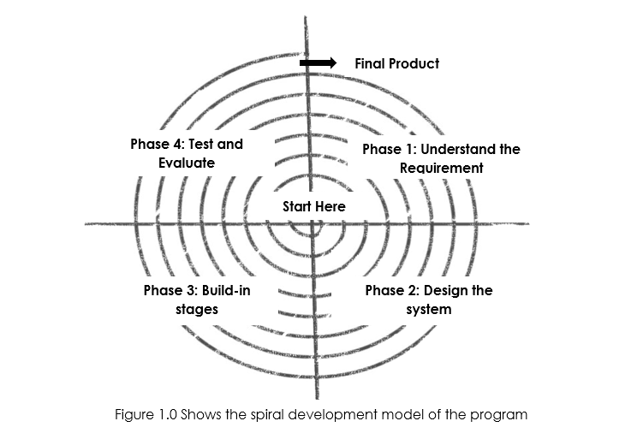

***Figure 1.2.*** Shows the Spiral Development of the Program

The figure above shows the developmental model of **Web-View:** A Web-based TLE Reviewer for the preparation of Industrial Arts Students in Licensure Examination for Teachers

**Phase 1: Understand the** **Requirement**

In this stage, the users were consulted to determine the system's services, limitations, and objectives. Users should be able to understand it, and there should be open lines of communication. The researchers specify the knowledge and resources required for creating the suggested system. The researchers also looked at the issue of why the proposed system was necessary.

**Phase 2: Design the system**

The data collection and gathering are used as a crucial means of acquiring the knowledge required to explain and support our research. The researchers thus utilized the following methods to collect data.

**Phase 3: Build-in stages**

It introduced overall system designing, which entails expressing software system operations in a way that one or more executable programs can be created. The researchers created both the program coding and the original user interface design.

**Phase 4: Test and Evaluate**

The website was developed during this period as a collection of programs or program components. The purpose of unit testing was to ensure that each unit complied with all requirements. To produce a suitable interface, the researchers were still developing the program. During this step, encoding and debugging also took place. The researchers examined and explained the data collected using a weighted mean and t-test. Web-View was created during this phase, which was followed by testing. Thus, testing and development were conducted throughout this phase.

The spiral development model figure shows the program's lifecycle method. It allows for incremental product releases, refinement via each spiral phase, and the construction of prototypes. The figure consists of 4 phases—phase 1, where to understand the program's requirements. Phase 2 consists of the system's design, phase 3 consists of build-in stages, and lastly, phase 4 is to assess and evaluate the product by the student and teachers of CIE College-TUP Manila

Output refers to the outcome based on the knowledge requirement from the input and the phase-by-phase procedure from the process. For this study, the expected output was the Web-View: A Web-based TLE Reviewer for the preparation of Industrial Arts Students in Licensure Examination for Teachers

# Operational Definition of Terms

For better understanding of this study, the following terms are defined in the context of this research.

**CSS**- (Cascading Style Sheets) allows you to modify the content's font, color, size, position, background, and spacing to suit your preferences. You can expand it into several columns or add animations and other aesthetic features based on the user's liking.

**HTML**- The standard markup language for Web pages is HTML. You can develop your own website using HTML. it is the code that is used to organize the content of a web page. Content may be arranged using paragraphs, a list of bulleted points, graphics, and data tables, for instance.

**Java script-** Javascript is a software programming language that allows users to accomplish a variety of things, including manage multimedia, animate visuals, and produce dynamically updating information.

**PHP**- Many developers utilize PHP, an open-source server-side scripting language for web development. It is also a general-purpose language that you may use to create a variety of applications, such as Graphical User Interfaces (GUIs)

**VS Code** - The optimized code editor Visual Studio Code provides debugging, implementation, and version control. It aims to give developers only the tools they require for a short cycle of code-build-debugging. It also leaves more sophisticated processes to IDEs with more features, like Visual Studio IDE.

**Website**- a compilation of World Wide Web pages typically linked to one another and made available online by an individual, business, institution, government, or other organization.

**Xampp**- Before publishing a website to the primary server, XAMPP enables a local host or server to test it on desktop and laptop computers and clients. The most important parts of the package can be password protected with a particular tool. Creating and managing databases in MariaDB and SQLite are only a few features supported by XAMPP.

**Chapter 3**

# Research Methodology

This chapter presents the development of the project. This discusses the project design, project development, procedures, testing and operation procedures, and evaluation strategy.

# A. Project Design

The development of **Web-View:** A Web-based TLE Reviewer was programmed using Programming language and Database engine such as HTML, CSS, PHP, and Java Script. This project was developed for the CIE BSIE IA Students reviewing for the Licensure Examination for Teachers (LET). It was envisioned as being an effective, efficient, accurate and reliable system capable of complying with different TLE specialization questions and questionnaires uploaded by the Teachers.

***Figure 2.*** Context Diagram of Web-View

The website design of the **Web-View:** A Web-based TLE Reviewer is showed in Figure 3. This illustration is a context of web based that shows the net inputs and outputs. The admin has different context view from the user, it shows the internal data of the website programming language or the Integrated Development Environment (IDE) while the user can only access its external function.

**Use Case Diagram** 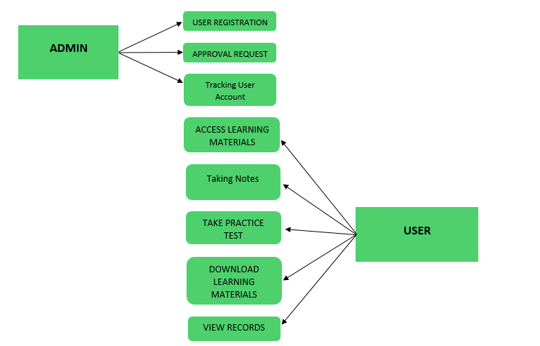

***Figure 3.*** Use Case Diagram for the Web-View

Figure 4 presents the Use Case Diagram which captures the website's behavior or functioning. The Web-View further shows the availability of both actors. The website system is designed such that the two actors namely Admin and User, interact with the module as directed in arrows. The Admin and Student/User can perform all functionalities of the Web-View. However, for security and better management of the data, the students/users are not granted access such that they cannot add, edit and delete questions and even the Learning Materials content.

# System Flowchart

The figure below shows flow of data for the user, from the opening of the

website, login, dashboard, TLE learning Materials, to other features of the Web-View until the sign out.

Web-View Student/User Access Flowchart 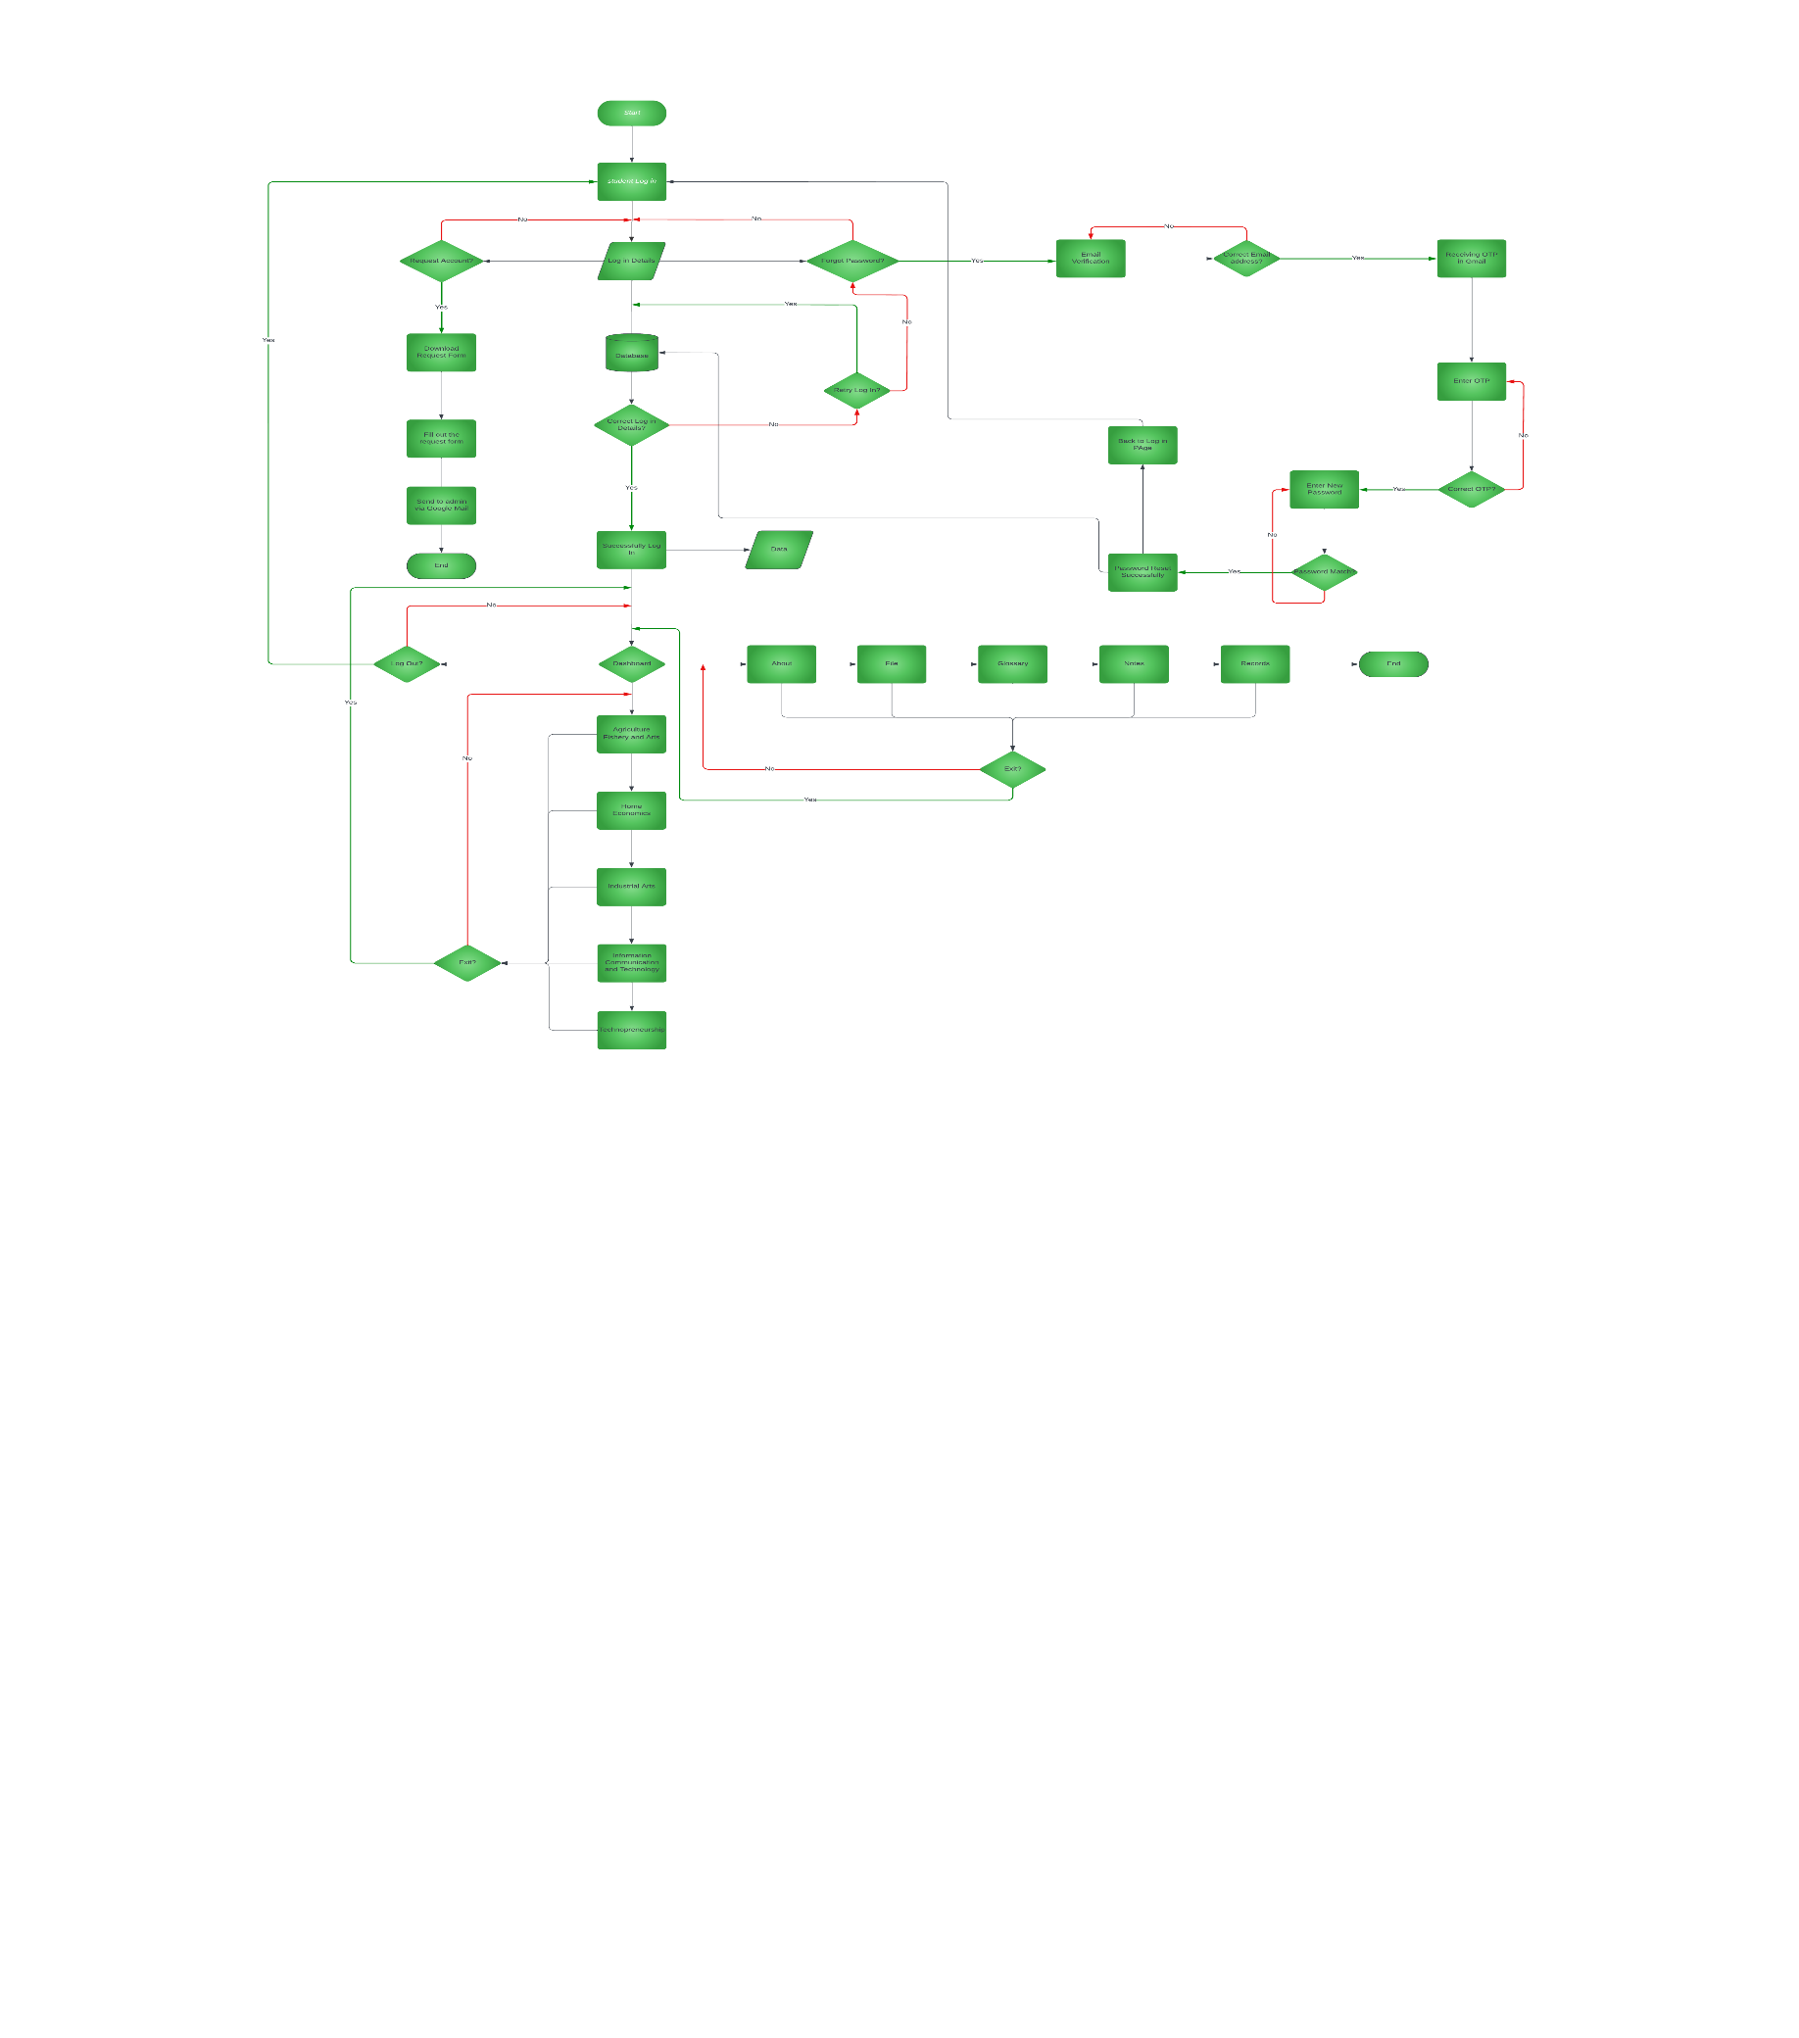

***Figure 4.*** System Flowchart (Student/User)

The operating procedures for the flow chart of Figure 4 are the following:

1. The student will open the Web-View using their desktop/laptop or phone device (desktop view). The student will enter the username or email address and password.
2. The website will display a dashboard for context and learning material modules of TLE specialized content, Website Developer About, Records, Notes and other Web-View features.
3. If the student chooses the view record bar, the project will show the student’s records and progress.
4. If the student chooses the learning materials library bar, the project will display option in which student are allowed to view and download the learning materials, take quizzes or practice test.
5. The project allows the student to go back to the main menu and if the user wanted to end the access. The student can log out his/her account.

Web-View Admin Access Flowchart 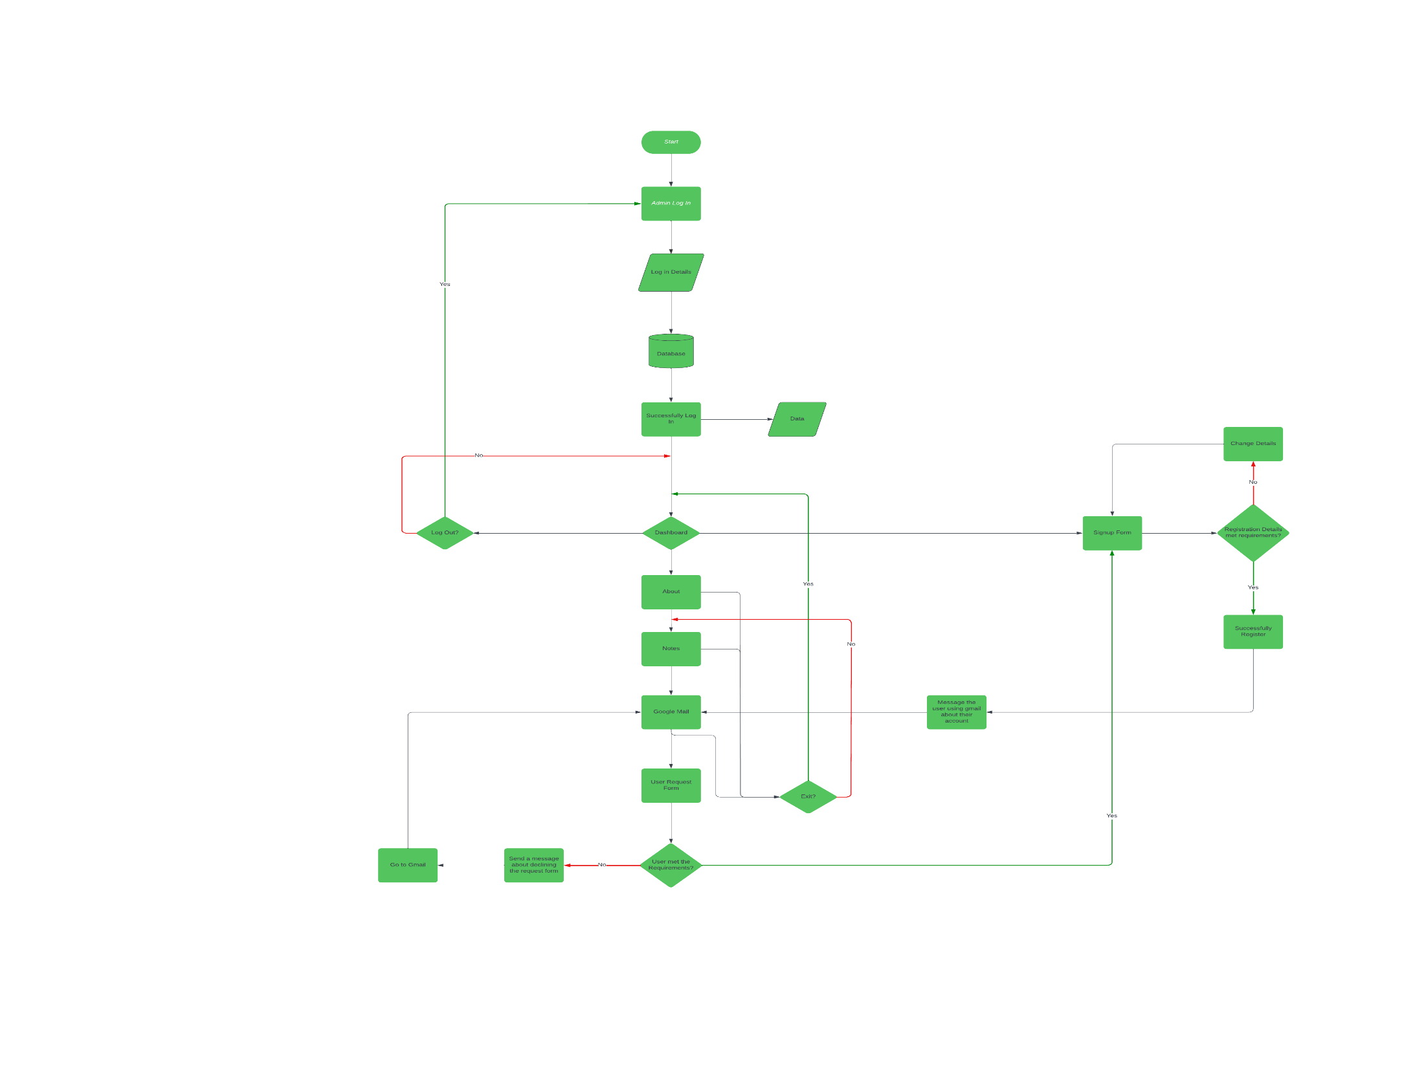

***Figure 5.*** System Flowchart (Admin)

The figure 5 illutrates the flow of data for the admin, from opening the website; login, dashboard (about, notes, google mail, user request form), sign up form for the user until the log out.

The operating procedures for the flow chart of Figure 5 are the following:

1. The admin will open the Web-View using desktop, laptop or phone. The admin will choose the administrator. After that, need to sign up the form that consist of; Name, email address, new pass word, date of birth, and gender.

2. Once the sign-up process is done, the website will display a dashboard, log out, and sign-up form for the user.

3. The admin needs to sign up first the user, to access the website.

4. When the admin chooses to view the dashboard it contains; notes, google mail, and user request form. This maintains the user’s security.

5. The website allows the admin to go back to the main page if the administrator wants to end the access and the admin can now log out of the account.

# B. Project Development

The development of the Web-View: A Web-based TLE Reviewer for the preparation of Industrial Arts Students in Licensure Examination for Teachersundergo with the waterfall development method. Waterfall development methodology is a sequential development process that moves like a waterfall through all project phases (such as analysis, design, programming, and testing), with each stage finishing entirely before the subsequent one starts. This phase includes analysis, design, development, testing, and evaluation.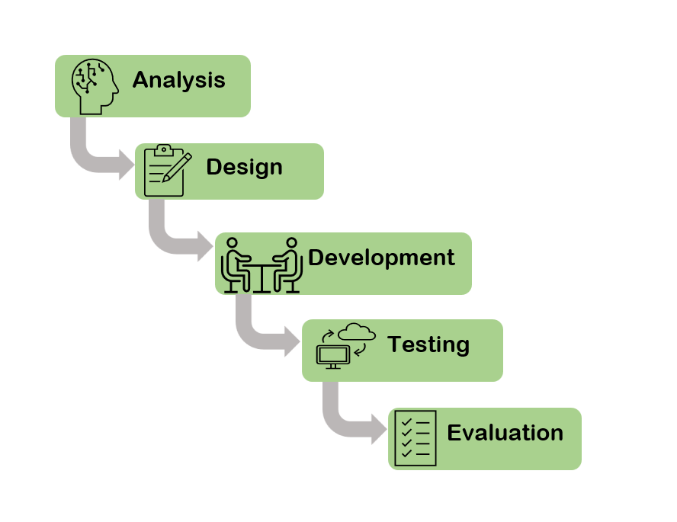

***Figure 6.*** Waterfall

***Analysis***

At this stage, it was determined what the system needs to do for the users/students and teachers. All inputs such as knowledge requirement, software requirement, and hardware requirement were combined to achieve the desired output. It included determining which appropriate programming language to use and utilize for the website's design and for the database system for its efficient functioning and operation.

***Design*** 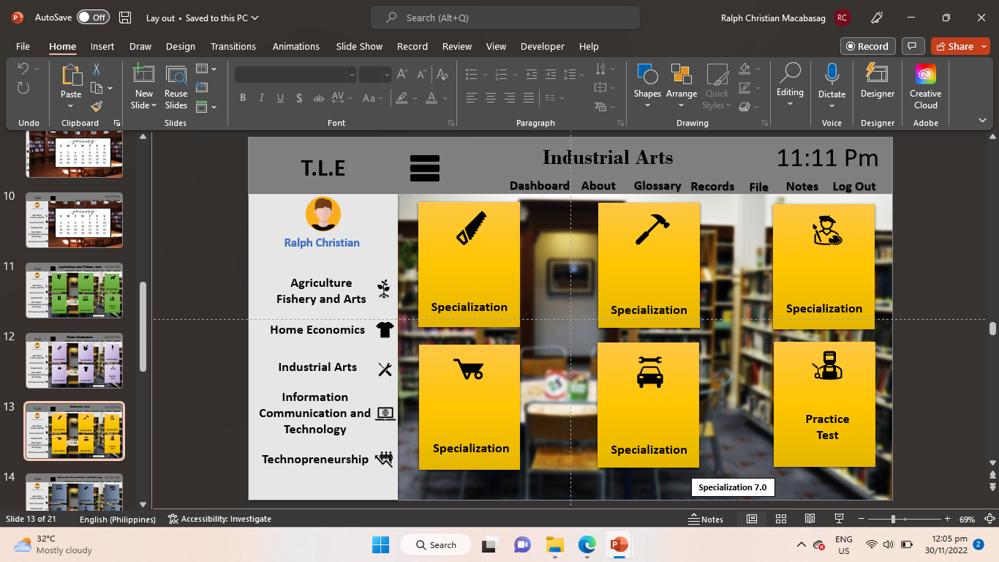

***Figure 7.*** Web-ViewInterface Design

The Figure 7 illustrates the Interface design of Web-View, it designed using a PowerPoint presentation; the dashboard will feature the user's profile photo and, below it, the sub-topics under TLE subjects composed of Agri- fishery Arts, Home Economics, Industrial Arts, Information, and Communication Technology and Technoprenuership with each specialization. Students can also access the practice test section which assess the user's knowledge for each topic and the glossary, which contains a list of related words, records of their assessments, downloadable files that have been used on the various topics, and the log-out icon.

***Development***

In the development phase, the following will be utilized: Visual Studio Code, Java script, Hypertext Preprocessor, HTML, Cascading Style Sheet (CSS), and Xampp.

***Figure 8.*** Building Web-View using Visual Studio Code 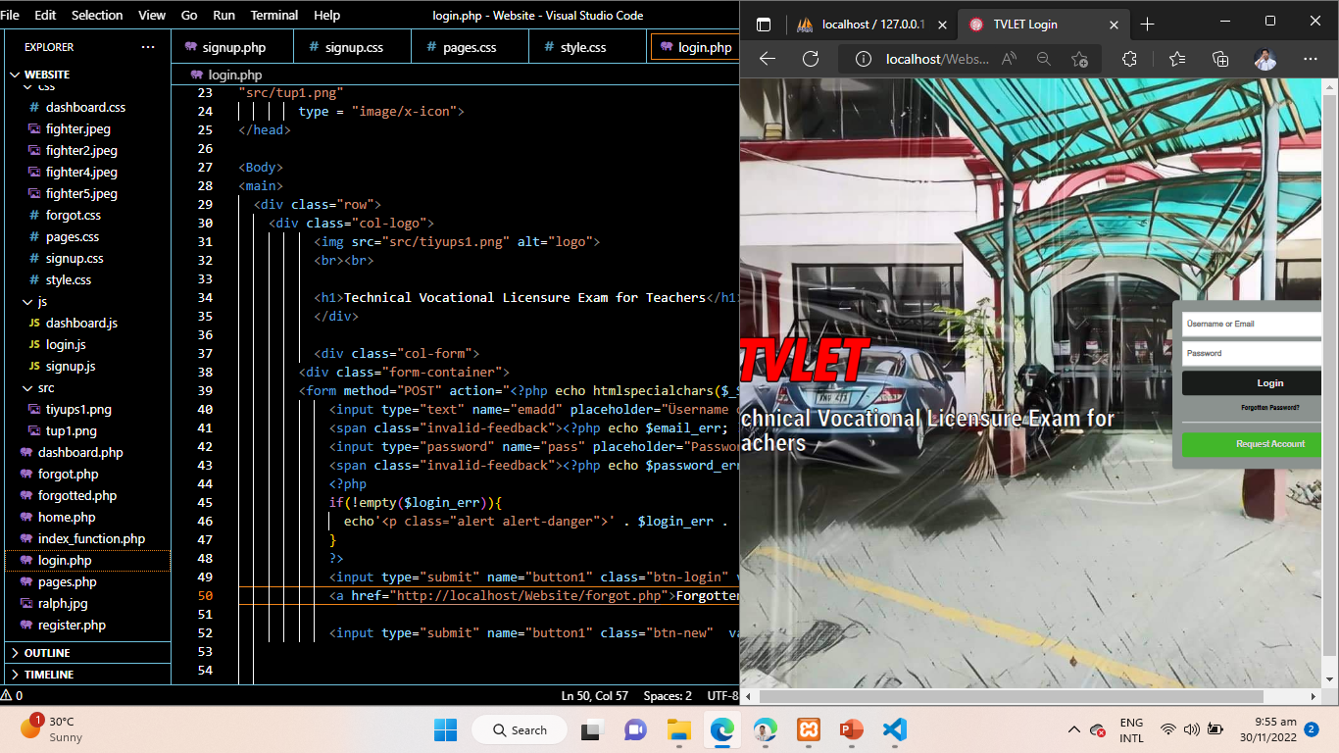

Figure 8: A technology based on a programming language called Visual Studio Code was used to construct Web-View. Visual Studio Code is efficient, although you may edit and debug codes in real time. Additionally, it has a feature that highlights the code in different colors so that coders can quickly identify coding trends and follow down problems. The researchers enter the necessary website codes using Visual Studio Code, the repository for all programming-related codes.

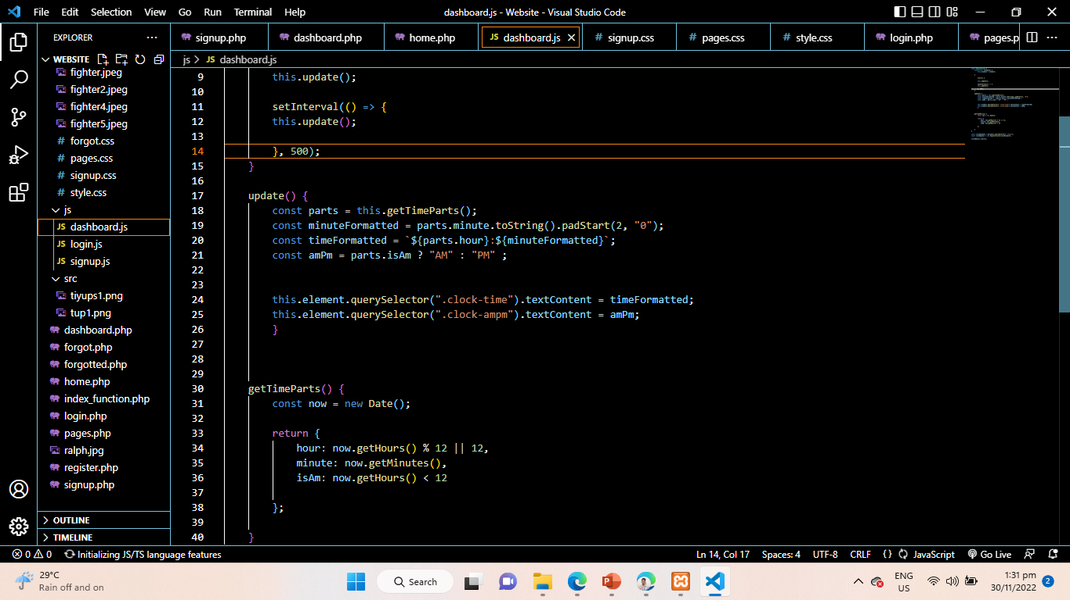***Figure 8.1.*** Building Web-View using Java script

Figure 8.1: The development of Web-View also incorporates Javascript, whose purpose is to do away with the limitations that static web pages impose on web pages and to use Java to create a scripting language specifically for the web. Faster code execution, dynamic page loading, memory efficiency, the development of user interfaces that respond to the user, and form validation were all made possible by its introduction. The researchers employ Javascript to build a fully functional website that runs on every browser, including Chrome and Firefox. Javascript is used as logic to create features, particularly the Web-View registration form.

***Figure 8.2.*** Building Web-View using Hypertext Preprocessor 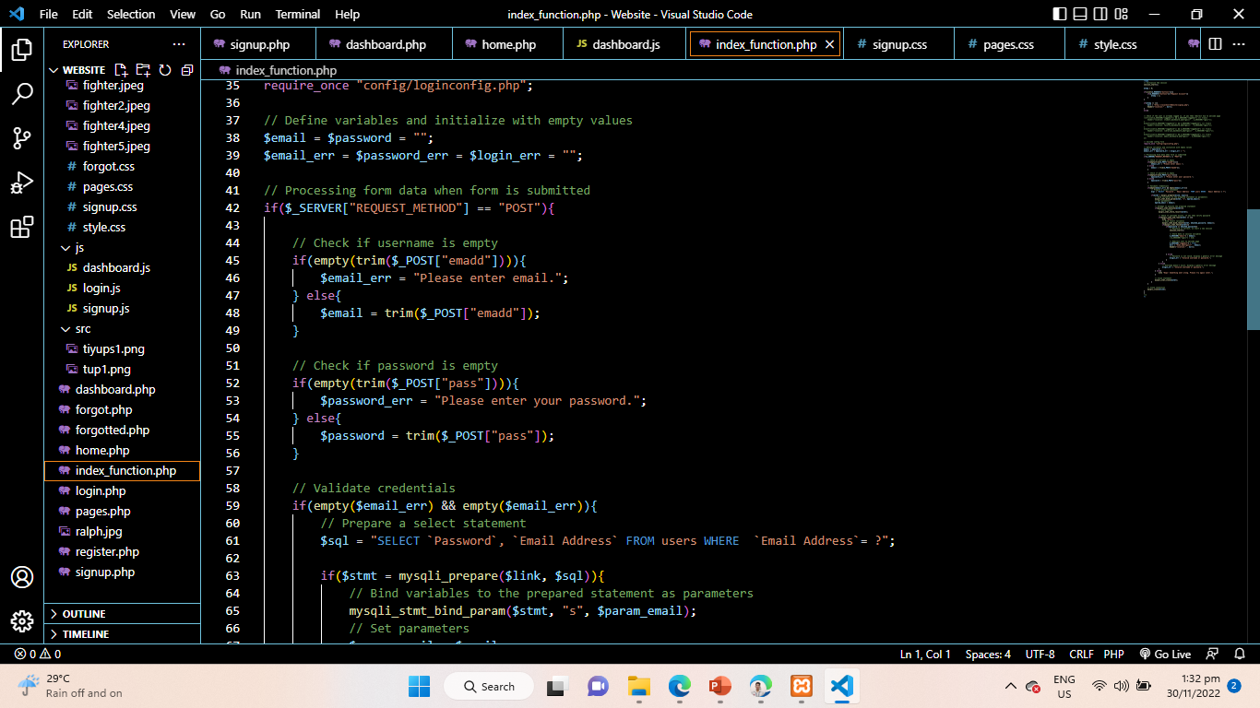

Figure 8.2: The Web-View uses the Hypertext Preprocessor to store user data like usernames and passwords for databases. It oversees how easily users may log in and out of the Web-View. When a user logs in, PHP collaborates with the database to enable the user to log in and access their information.

***Figure 8.3.*** Building Web-View using Hypertext Markup Language (HTML)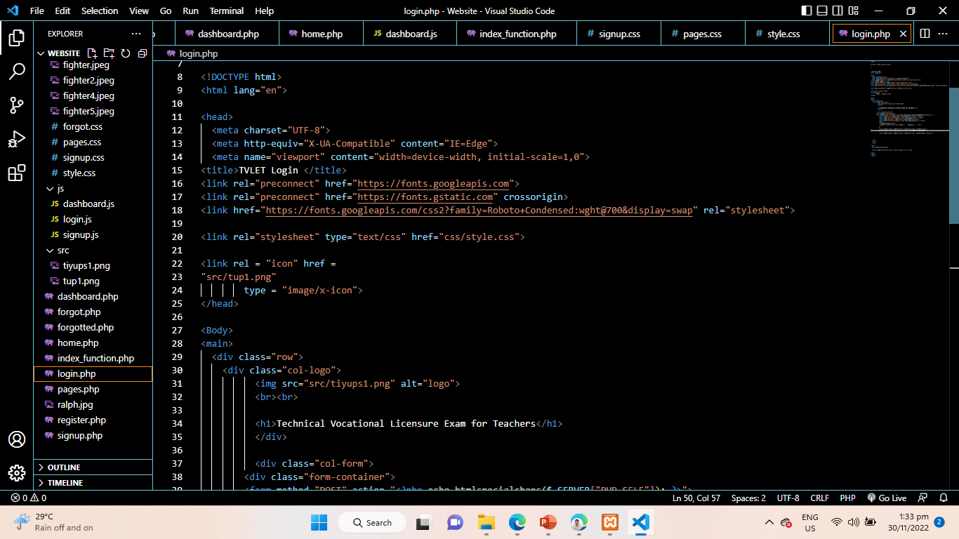

Figure 8.3: The Web-View structure is HTML. It acts as a container for codes by way of structure. Similar to a document that can open and show a webpage, HTML. HTML gives instructions on how text should be organized, formatted, and displayed on Web-View . The researchers reveal information to users using HTML, such as the tabs comprising the Industrial Arts lesson.

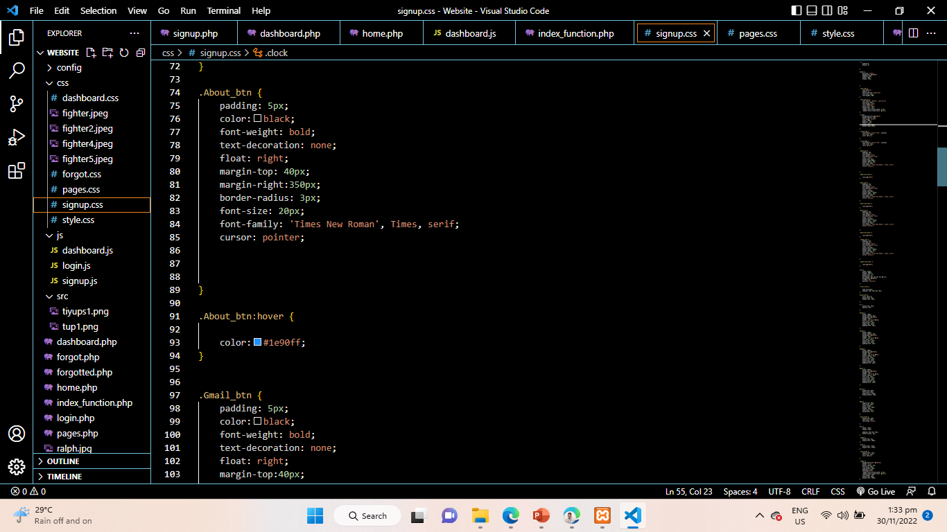

***Figure 8.4.*** Building Web-View using Cascading Style Sheet (CSS)

Figure 8.4: Web-View uses CSS to style the text by altering the font, color, size, spacing, bold, italic, drop shadows, line and letter spacing, and other text-related features. CSS is responsible for TVLET's appearance and style. The title, colors, size, and other aspects of TVLET, as depicted in Figure 8.5, are the responsibility of Cascading and Style. The Sheets are in charge of applying to Web-View’s structure and content.

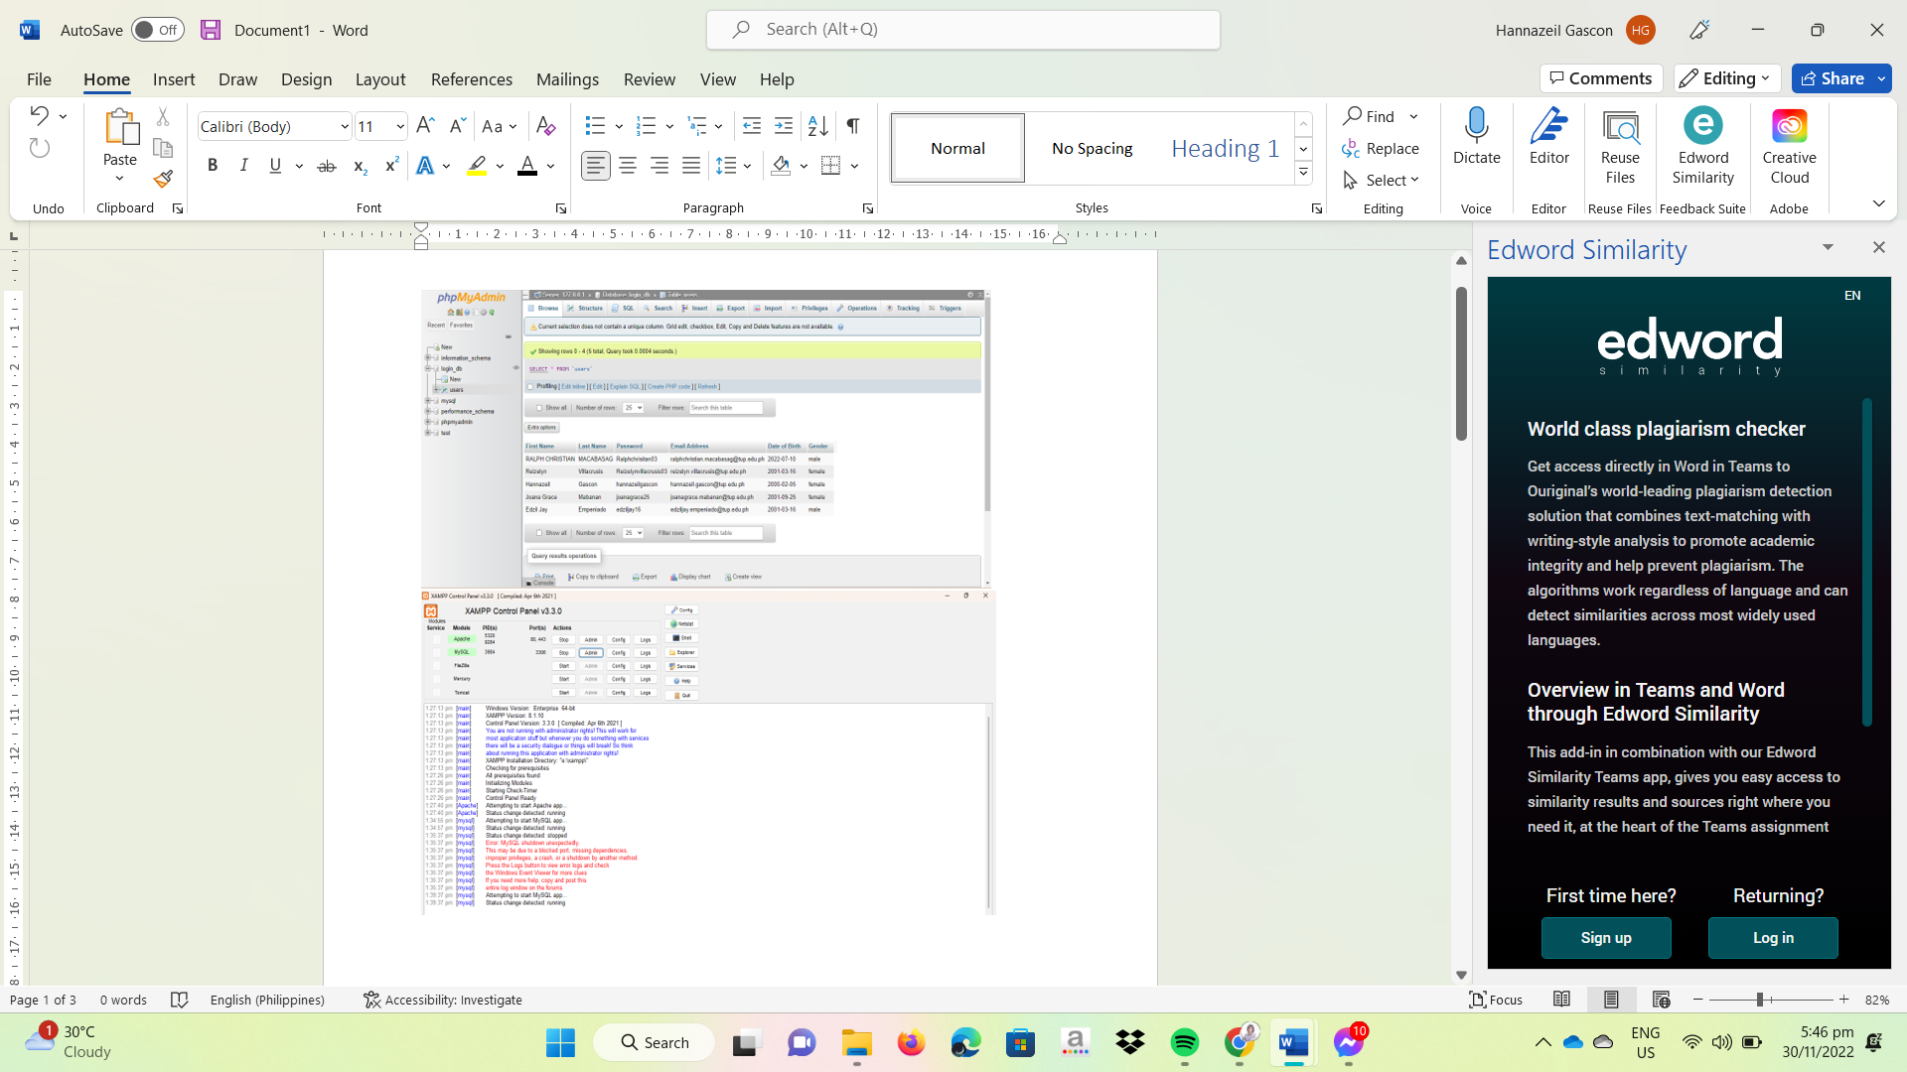

***Figure 8.5.*** Building Web-View using Xampp

Figure 8.6: On the Web-View, Xampp is used to develop and test programs on a local web server. Before deploying Web-View to the primary server, the researchers find it helpful to try it on a computer or laptop.

***Testing***

The developed website was tested using the following criteria to ensure that it meets the desired output.

1. Accuracy

a. Open Programming Language Converter platform.

b. Create a new project and edit the program source code or open an existing sample program.

c. Compile the program source code.

d. Convert the program source to another equivalent program source code.

e. Run the successfully compiled program source code.

***Evaluation***

To see if the Web-View really performs what it intends to perform, and functions accordingly as to how it was created, evaluation should be done, just like any other web-based product.

The evaluation is an essential process that comes before the implementation of the developed project. This step serves as the check and balance of all the elements present in the system website’s.

**ISO 9126**

ISO 9126 is an international standard for the evaluation of software. It was guided by ISO/IEC 25000:2005 and a series of international standard called Software product Quality Requirements and Evaluation. (Buenaflor, 2017) The standard has four sections that include the quality model, internal metrics, external metrics and quality in use metrics. It identifies (6) six main quality characteristics namely: functionality, reliability, usability, efficiency, maintainability and portability.

**Functionality.** It includes sub-characteristics such as suitability, accuracy, interoperability, compliance, and security. Suitability refers to the appropriateness of the software specifications: Accurateness refers to the correctness of the functions: Interoperability refers to the ability of the software components to interact with each other. Compliance refers to the software's ability to comply with the requirements: While security is the ability of the software to protect it from unauthorized access.

**Reliability.** It consists of sub characteristics, namely maturity, fault tolerance, and recoverability. Maturity concerns the frequency of failure of the software: Fault tolerance refers to the ability of the software to resist failures: Recoverability refers to the ability of the software to bring back the failed system into operation.

**Usability.** It contains sub-characteristics such as understandability, learnability, and operability. Understandability defines the ease with which system functions can be understood: Learnability defines the ability of the user to learn from the system: Operability refers to the ability of the software to work in a specified environment.

**Efficiency.** It includes two sub-characteristics, namely time behavior and resource behavior. Time behavior characterizes response time for a given output, and Resource behavior defines the resources used.

**Maintainability.** It consists of sub-characteristics such as analyzability, changeability, stability, and testability: Analyzability describes the ability to recognize the root cause of failure within the software: Changeability characterizes the amount of effort to modify the system: Stability illustrates the sensitivity of the system to be changed: Testability describes the effort needed to check the system change.

**Portability.** It encompasses four sub-characteristics, namely adaptability, installability, conformance, and replaceability: Adaptability refers to the capability of the system to adapt to new specifications or operating environment: Installability describes the effort needed to install the software: Conformance refers to the ability to meet the requirements: Replaceability defines the plug and play aspect of software components.

# C. Operation and Testing Procedure

This section enumerates the different steps to be followed in the operation of the Web-based TLE Reviewer “WEB-VIEW” and the test procedures required to ensure that the website performs according to the specified requirements. The Web-View will be subjected to a test in terms of its functionality and reliability.

**Operation Procedure**

The students/users used the following procedures to run the Web-View:

***Figure 9.*** Web-View Sign in / Sign up for student/user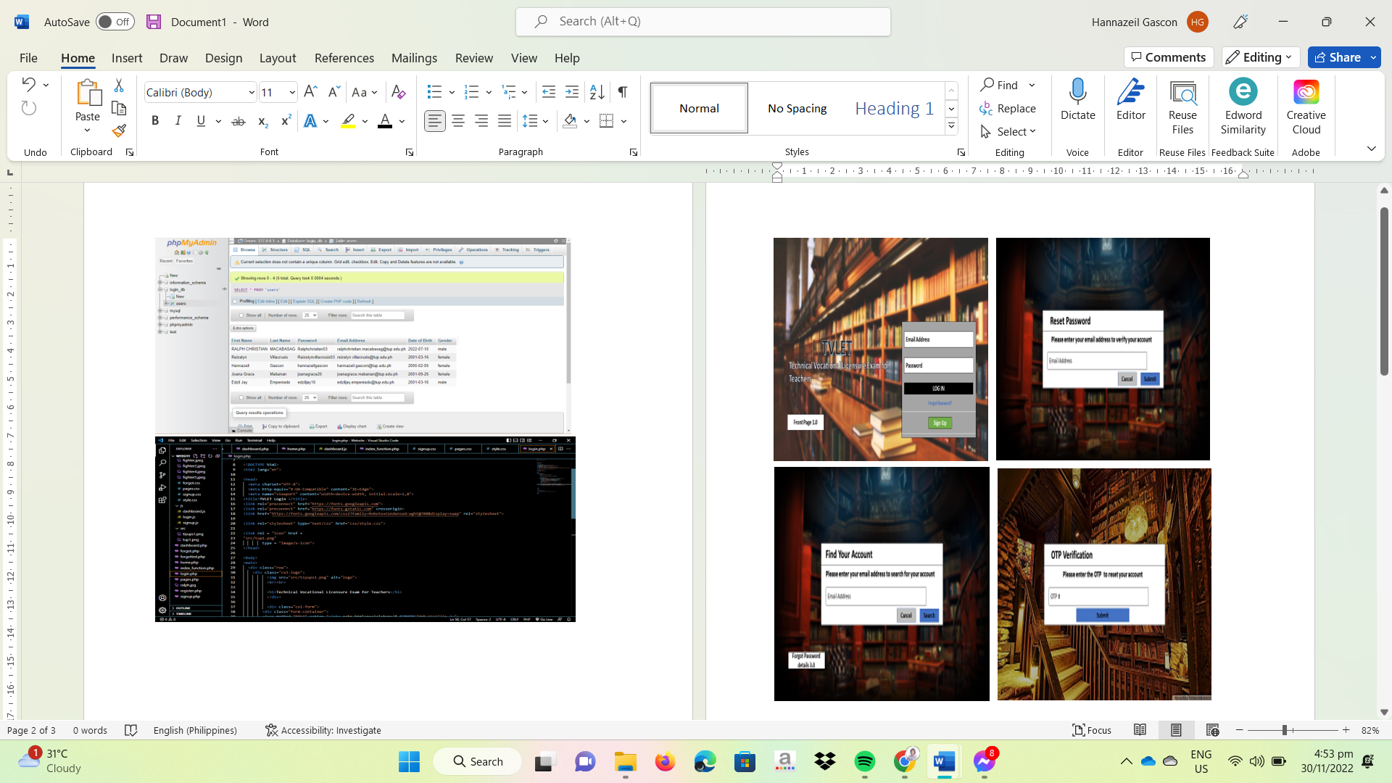

**Step 1:**  Register your account on the website, fill in the information needed, and once the account has been created, proceed to fill in the login form. If the account has been specified, you may change the password via forget password bar; then, it will move to send email links to have confirmation for data privacy purposes and fill up the information needed to complete the action.

***Figure 9.1.*** Web-View Dashboard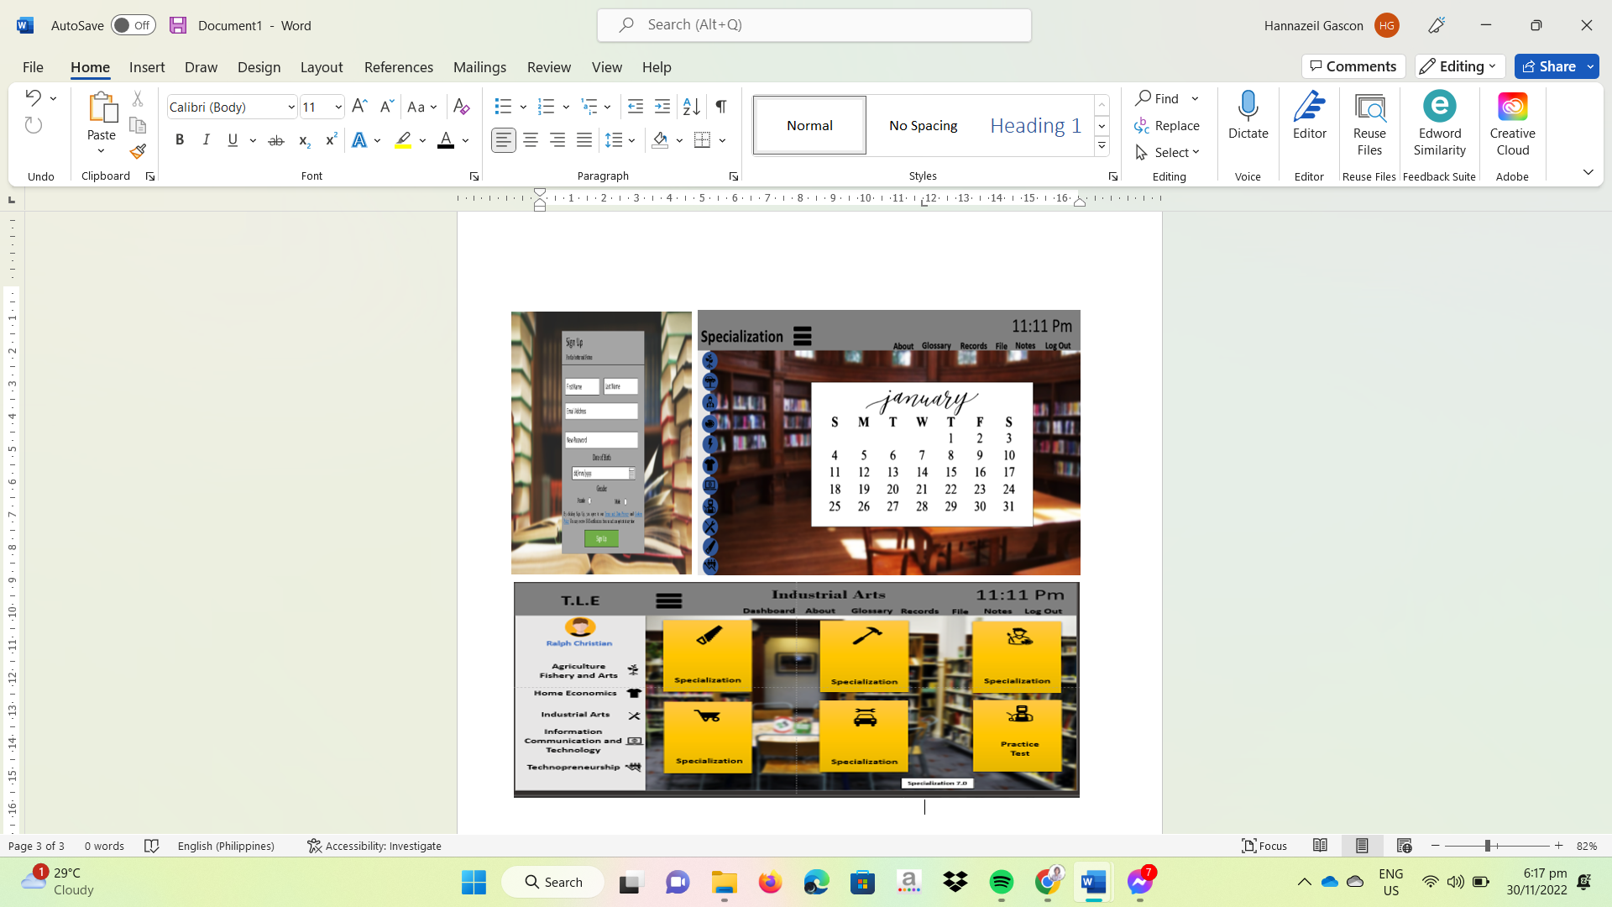

**Step 2:** Login and access the dashboard. The dashboard will feature the user's profile photo and, below it, the sub-topics under TLE subjects composed of Agri- fishery Arts, Home Economics, Information, and Communication Technology and Industrial Arts with each of its specialization. In exploring the dashboard, the USER can access every module in TLE specialized subject covered by the Web-View by clicking on the side bars.

***Figure 9.2.*** Web-View Practice Test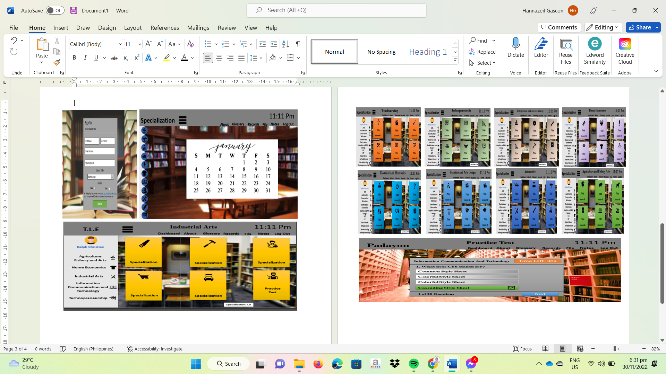

**Step 3:** At the end of each session, a practice test will be given to see how well the user understands the material. This will help them determine which topics they have mastered and motivate them to concentrate their future learning on their weak areas. 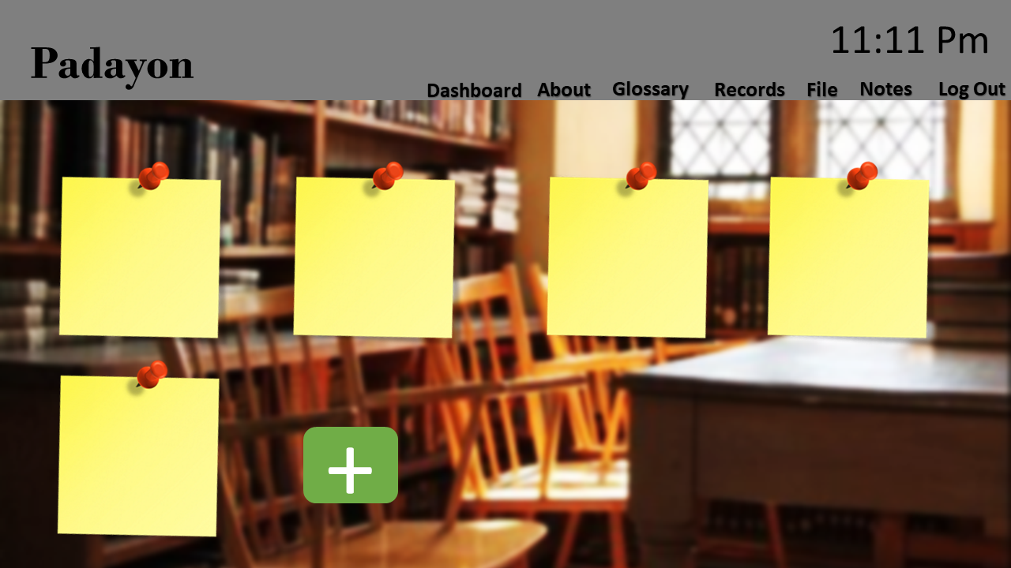

***Figure 9.3.*** Web-View Notepad

**Step 4:** Before, During, or After exploring every specialized subject, the user can use the notepad features wherein a text from the Windows clipboard can be pasted into Notepad. The only text that Notepad will accept when pasting data from the clipboard in different forms is text in the CF TEXT format. This is helpful for removing embedded font type and style codes from the prepared text when copying and pasting content from a web page into an email or another WYSIWYG text editor. The user can make notes after reading and studying on the Web-View on anything they want to jot down, highlight, or go back and review when they have free time.

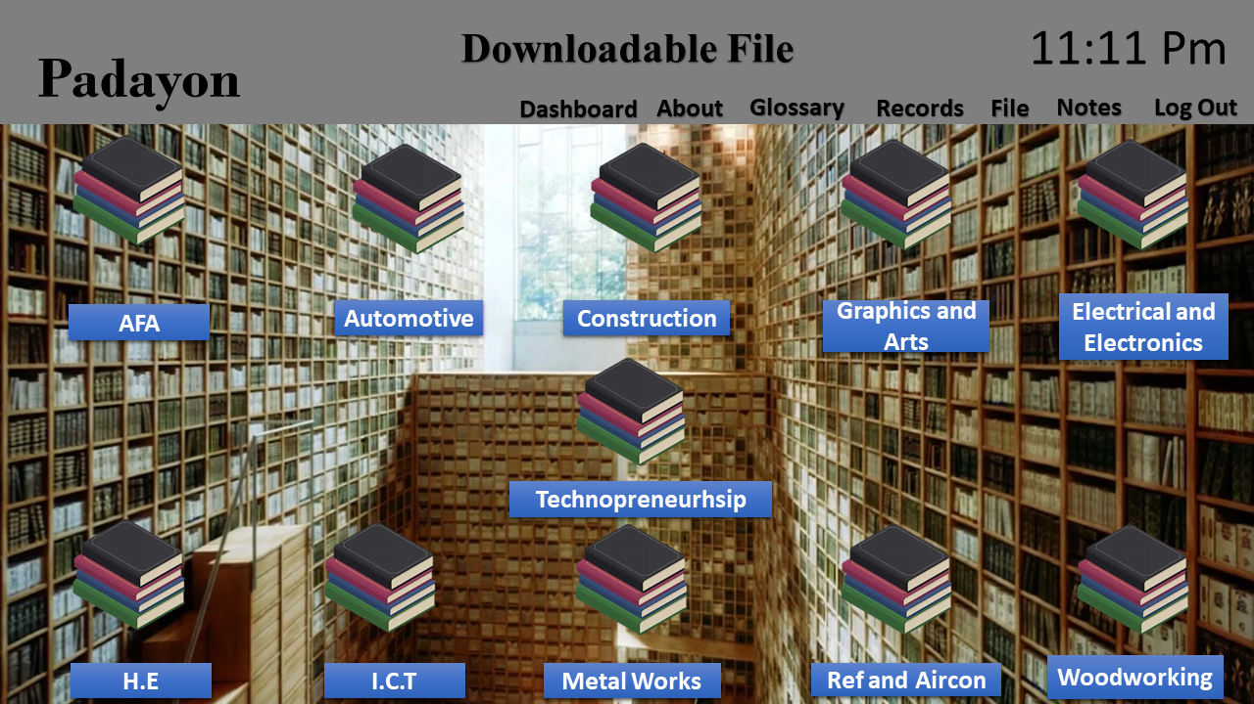

***Figure 9.4.*** Web-View Downloadable Files

**Step 5:** The user can download the used files for each subject to utilize and review the courses online and offline, studying the subjects whenever and wherever it is suitable for them by clicking the download button of each course.

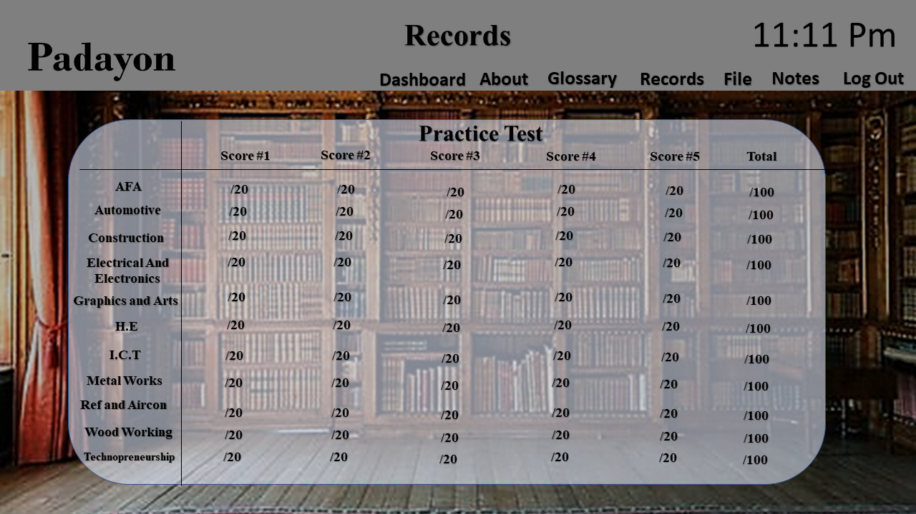

***Figure 9.5.*** Web-View Record Status

**Step 6:** You can check your progress and status as often as you'd like by clicking the Records button. It will maintain a record of your previous reading, viewing, and practice test results so you can monitor your development and progress. After checking the score, the user results of assessments will be recorded so that the user may examine and track their progress and go back to any topics they wish to or need to improve.

***Figure 9.6***. Glossary and Web developer About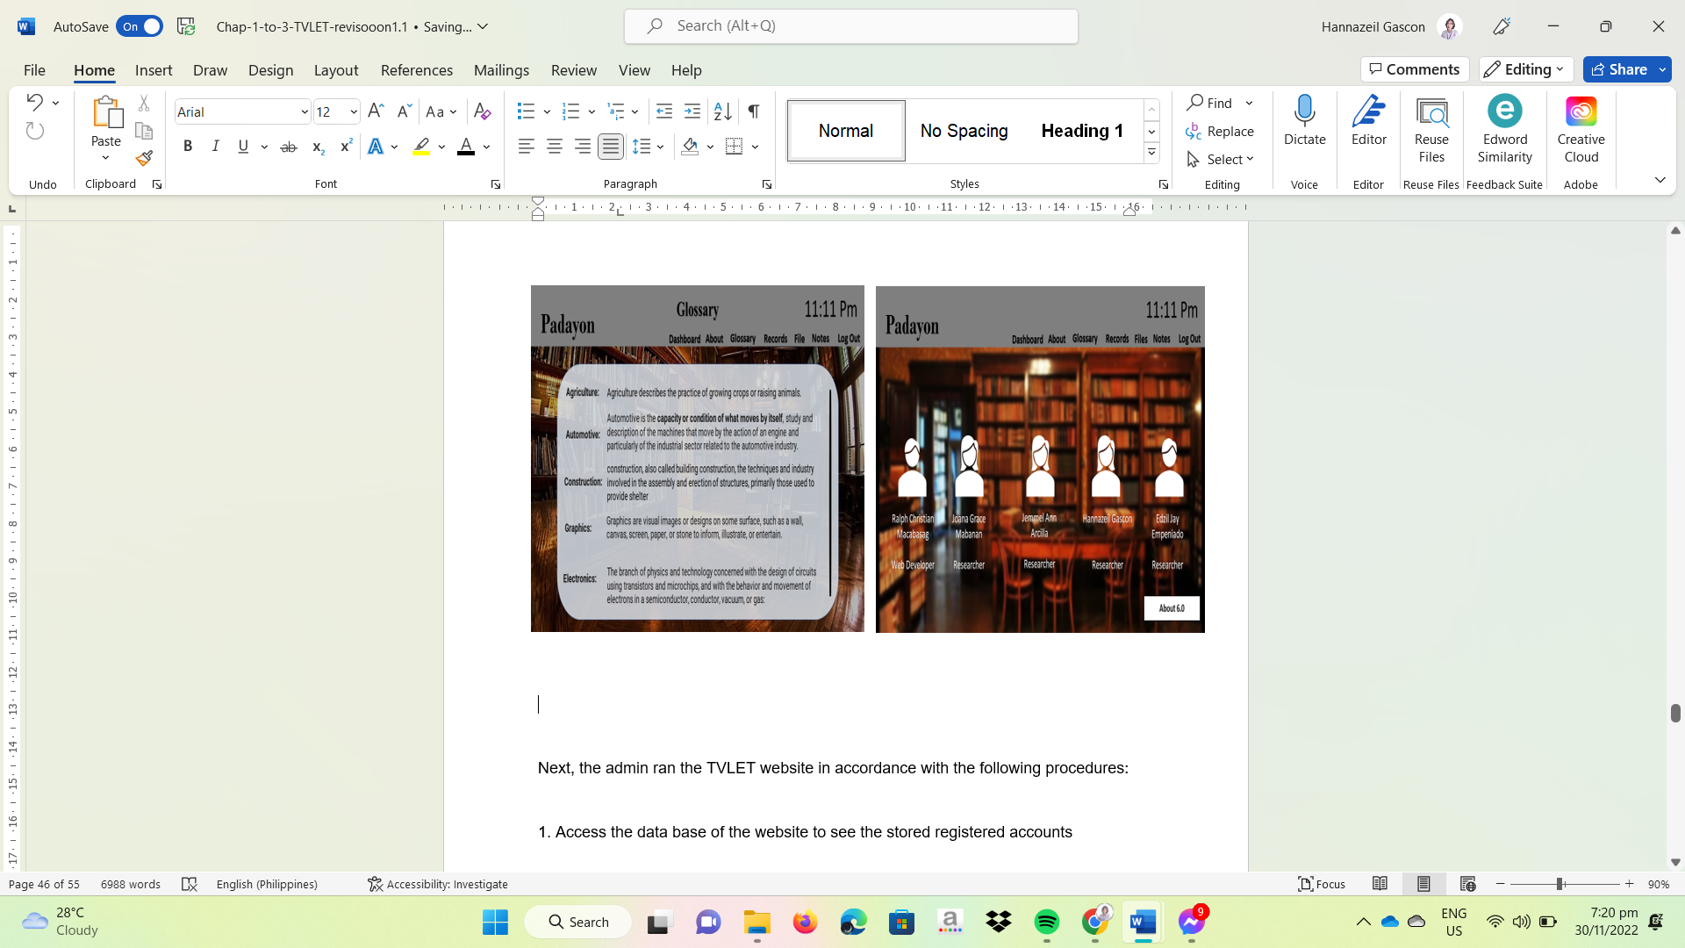

**Step 7:** The glossary section is where users can look up words they need to familiarize themselves with. The glossary also contains lists of terms related to specific topics. Additionally, there is a section called "about" where information from researchers and developers can be accessed.

Next, the admin ran the Web-View in accordance with the following procedures: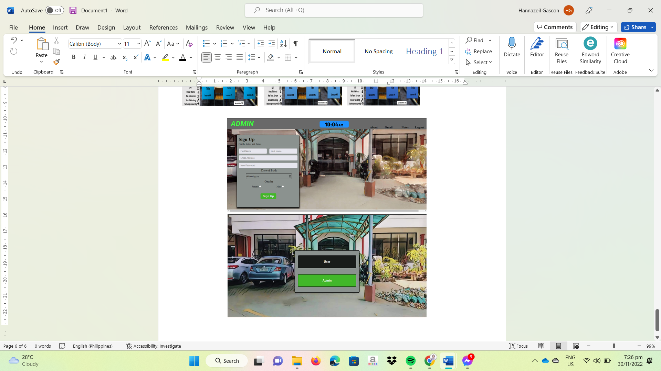

***Figure 10*** Web-View Sign in / Sign up for admin

**Step 1:** Fill up the necessary information for Sign Up to access the sign-up operation of the website by clicking the Admin button. By doing that they can access the database of the website to see the stored registered accounts and can access created accounts.

**Testing Procedure**

For the Functional Testing, the following procedures will be carried out:

1. The student chooses a course subject he/she likes to answer

2. The student will review the contents of subject

3. The student will answer the quiz prepared based on the subject the student reviewed.

4. The submitted answer will be interpreted

As for the Reliability Testing, the performance of the Web-View will be based on the following:

1. Run the website by logging in on a laptop

2. Record the data on the progress of the website

3. Evaluate and analyze the results

# D. Evaluation Strategy

In this section, after the implementation of **Web-View:** A Web-based TLE Reviewer to the student/user, the next step to conduct is the evaluation. The potential respondents of this study are the students of Bachelor of Science In industrial Education Major in Industrial Arts 4th year Sections A and B at the Technological University of the Philippines-Manila. It uses a probability method that includes cluster sampling. Wherein the researchers select respondents that are currently available for the study without a specific pattern. Considering the population size of 89 students, thirty-one (31) respondents will evaluate the system, three (3) respondents from the expert teachers, and twenty-eight (28) respondents from the Industrial Arts students. The researchers use the slovin formula calculated using the raosoft website with a confidence level of 50% and 0.05 margin of error: the system will be evaluated through its functionality, reliability, efficiency, maintainability, and portability.

To assess the acceptability of the Website, teachers and students will be given a set of assessment forms. Each of the criteria in the evaluation form was rated on a scale of one (1) to five (5), five (5) being the highest (or highly acceptable) and one (1) being the lowest (or not acceptable).

The evaluation procedures were as follows:

1. The assessors will be given an evaluation form.
2. The Website will be presented to the assessor and given a chance to use and evaluate its performance.
3. The respondents will access the Website by rating the Websites performance.
4. The results will be gathered, tabulated, and computed using the mean rate to conclude the performance of the Web-View.

**Treatment of Data**

The evaluation results were tabulated and interpreted. The project's acceptability level was determined using the weighted mean x. The formula is as follows.

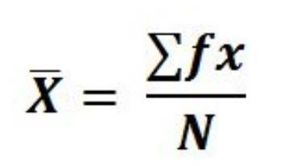

**Where:**

x = weighted mean

Fx = summation of the product of frequency and weight

N = total number of respondents

A rating scale known as a Likert Scale is employed to evaluate perceptions or points of view. This scale is utilized to ask respondents to rate items based on their level of agreement. The following Likert Scale serves as the guide for interpreting the data gathered:

|  |  |
| --- | --- |
| Weighted Mean | Descriptive Equivalent |
| 4.51-5.00 | Highly Acceptable |
| 3.51-4.50 | Very Acceptable |
| 2.51-3.50 | Acceptable |
| 1.51-2.50 | Moderately Acceptable |
| 1.00-1.50 | Not Acceptable |

***Table 1:*** Scoring System

# BIBLIOGRAPHY

Bee Bee Chua, & Dyson, L. (2017). *Applying the ISO 9126 model to the evaluation of an e- learning system*.<https://www.semanticscholar.org/paper/Applying-the-ISO-9126-model-to-the-evaluation-of-an-Chua-Dyson/a9fea1ec3ef593025ff52a9072300c3196db1298>

Chris, K. (2021, August 30). *What is PHP? The PHP Programming Language Meaning Explained*. FreeCodeCamp.org; freeCodeCamp.org.<https://www.freecodecamp.org/news/what-is-php-the-php-programming-language-meaning-explained/>

Cueva, D. (2018, December 30). *The Ultimate LET Reviewer 2021 (Gen. Ed, Prof. Ed. and Major)*. TOPNOTCHER PH.<https://topnotcher.ph/online-let-reviewer/>

*CSS | Information Technology Competency Test Study Guide*. (2022). Unc.edu.<https://infotechstudyguide.web.unc.edu/creating-web-documents/css/#intro>

Fuente, J. K. de la. (2022, August 8). *Overall Passing Rate in Licensure Examination for Teachers (LET)*. TeacherPH.<https://www.teacherph.com/overall-passing-rate-licensure-examination-teachers->

GCFLearnFree.org. (2021). What is HTML? [YouTube Video]. In *YouTube*.<https://www.youtube.com/watch?v=xKuJrmlCdig>

GeeksforGeeks. (2019, October). *Difference between Java and JavaScript - GeeksforGeeks*. GeeksforGeeks.<https://www.geeksforgeeks.org/difference-between-java-and-javascript/>

*History of CSS*. (n.d.). Www.bu.edu. Retrieved November 1, 2022, from<https://www.bu.edu/lernet/artemis/years/2020/projects/FinalPresentations/HTML/historyofcss.html>

*HTML basics - Learn web development | MDN*. (2022, October 4). Mozilla.org.<https://developer.mozilla.org/en-US/docs/Learn/Getting_started_with_the_web/HTML_basics#:~:text=HTML%20(HyperText%20Markup%20Language)%20is,using%20images%20and%20data%20tables>.

Java | Definition & Facts | Britannica. (2022). In *Encyclopædia Britannica*.<https://www.britannica.com/technology/Java-computer-programming-language>

Kidder, T. J. (2020, February 10). *A Brief History of JavaScript*. LEARN Academy - San Diego’s Original Coding Bootcamp; LEARN academy.<https://www.learnacademy.org/blog/who-introduced-javascript-originally-called-why-created/#:~:text=Brendan%20Eich%20created%20JavaScript%20in,it%20available%20in%20Netscape%20Communicator>.

Lew, P., Abbasi, M. Q., Rafique, I., Wang, X., & L. Olsina. (2012). *Using Web Quality Models and Questionnaires for Web Applications Understanding and Evaluation*. Undefined;<https://www.semanticscholar.org/paper/Using-Web-Quality-Models-and-Questionnaires-for-Web-Lew-Abbasi/f9e7f410cd6088f8af9aa4276c1a79af04b79b5c>

Mark Anthony Llego. (2017, October 23). *Top Reasons Why Most Takers Fail the Licensure Examination for Teachers (LET)*. TeacherPH.<https://www.teacherph.com/let-takers-fail/>

Microsoft. (2021, November 3). *Visual Studio Code*. Visualstudio.com; Microsoft.<https://code.visualstudio.com/docs/getstarted/userinterface>

Murphy, C. (2022). *12 Discovery Questions to Ask Freelance Web Development Clients*. Prismic Blog. [https://prismic.io/blog/discovery-questions-freelance-webdevelopment](https://prismic.io/blog/discovery-questions-freelance-web-development)

Olson, T., & Wisher, R. A. (2002). The Effectiveness of Web-Based Instruction: An Initial Inquiry. *The International Review of Research in Open and Distributed Learning*, *3*(2).<https://doi.org/10.19173/irrodl.v3i2.103>

[O](https://prismic.io/blog/discovery-questions-freelance-web-development)rekhova, K. (2022, July 27). *How to create a Q&A website like Quora*. Cleveroad Inc. - Web and App Development Company; Cleveroad Inc. [https://www.cleveroad.com/blog/how-to-build-a-question-and-answer-websitelike-quora/](https://www.cleveroad.com/blog/how-to-build-a-question-and-answer-website-like-quora/)

Peroni, S., Osborne, F., Di Iorio, A., Nuzzolese, A. G., Poggi, F., Vitali, F., & Motta, E. (2017). Research Articles in Simplified HTML: a Web-first format for HTML-based scholarly articles. *PeerJ Computer Science*, *3*, e132.<https://doi.org/10.7717/peerj-cs.132>

Pro. (2020). What is CSS? And How It Works! [YouTube Video]. In *YouTube*.<https://www.youtube.com/watch?v=XPv4EeB0PJ8&t=153s>

*Technology and Livelihood Education (TLE) and Technical-Vocational-Livelihood (TVL) Track | Department of Education*. (n.d.). <https://www.deped.gov.ph/k-to-12/about/k-to-12-basic-education-curriculum/technology-and-livelihood-education-tle-and-technical-vocational-livelihood-tvl-track/>

Treehouse. (2020). What is HTML? [YouTube Video]. In *YouTube*.<https://www.youtube.com/watch?v=W-6OY9eI3hk&t=110s>

*TUP Manila - board exam rankings*. (2022). Finduniversity.ph.<https://www.finduniversity.ph/BoardExamResultsForSchool.aspx?&b=8450>

‌ *Use of an Online Peer Review Tool to Support Feedback and Collaborative Skills in Preservice Teachers – CITE Journal*. (2021). Citejournal.org.<https://citejournal.org/volume-21/issue-2-21/general/use-of-an-online-peer-review-tool-to-support-feedback-and-collaborative-skills-in-preservice-teachers/>

*View of University Faculty and Student Perceptions of Web-Based Instruction | International Journal of E-Learning & Distance Education / Revue internationale du e-learning et la formation à distance*. (2022). Ijede.ca.<https://www.ijede.ca/index.php/jde/article/view/134/411#:~:text=Web%2Dbased%20instruction%20(WBI),learning%20is%20supported%20and%20fostered>.

*Visual Studio Code User Interface*. (2022). Code.visualstudio.com.<https://code.visualstudio.com/docs/getstarted/userinterface>

‌ *VS Code — The Story and Technology Behind One of the World’s Most Popular Desktop Apps for Developers*. (2021). Git-Tower.com.<https://www.git-tower.com/blog/developing-for-the-desktop-vscode/>

‌*WebD2: A Brief History of HTML*. (2022). Washington.edu.<https://www.washington.edu/accesscomputing/webd2/student/unit1/module3/html_history.html>

Winning. (2018). What is PHP, What Does It Do, And What Is It Used For? [YouTube Video]. In *YouTube*.<https://www.youtube.com/watch?v=Zrcg7w67Ots&t=102s>

*What are HTML and CSS used for? | the basics of web code*. (2021, June 3). FutureLearn.<https://www.futurelearn.com/info/blog/what-are-html-css-basics-of-coding>

*What is PHP?* (2021, November 22). One.com.<https://www.one.com/en/hosting/what-is-php>

Zwel's Sharing. (2020). what is xampp [YouTube Video]. In *YouTube*.<https://www.youtube.com/watch?v=LBOawcY9mak&t=28s>

# APPENDICES

Appendix A

Evaluation Instrument for Students

Name: ______(Optional)_______ Course / Year: ___________________

*Instructions: Rate the acceptability of the* **Web-View:** A Web-based TLE Reviewer for the preparation of Industrial Arts Students in Licensure Examination for Teachers *based on the given criteria.*

*Kindly put a check (/) to your answer.*

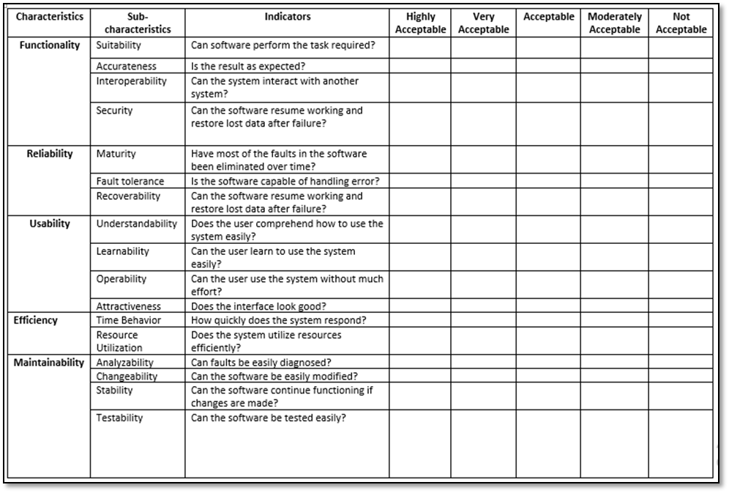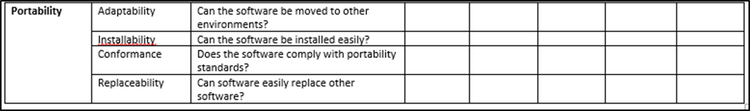

Remarks:

___________________________________________________________________

___________________________________________________________________ ___________________________________________________________________

________

Appendix A

Evaluation Instrument for Teachers/Experts

Name: ______(Optional)_______ Course / Year: ___________________

*Instructions: Rate the acceptability of the* **Web-View:** A Web-based TLE Reviewer for the preparation of Industrial Arts Students in Licensure Examination for Teachers *based on the given criteria.*

*Kindly put a check (/) to your answer.*

**

Remarks:

___________________________________________________________________

___________________________________________________________________ ___________________________________________________________________

________